**VIETNAM NATIONAL UNIVERSITY HO CHI MINH CITY**

**UNIVERSITY OF ECONOMICS AND LAW**

**FACULTY OF INFORMATION SYSTEMS**



**FINAL PROJECT**

**PRODUCTION SCHEDULE & INVENTORY CONTROL**

**SUPPORTING SYSTEM**

**Subject: Business Intelligence & Decision Supporting System**

**Instructor: MSc Nguyen Van Ho**

**MSc Nguyen Van Tuyen**

**Tutors: BSc Nguyen Anh Nhat**

**Group: OBD**

**Members of group:**

|  |  |
| --- | --- |
| Bùi Phương Nga | K194060857 |
| Nguyễn Hoàng Tuyết Nhi | K194060863 |
| Lê Thị Diễm Quỳnh | K194060869 |
| Nguyễn Đỗ Thanh Thùy | K194060873 |
| Nguyễn Thu Vân | K194060880 |

*Ho Chi Minh city, 26th May 2022*

**LIST OF GROUP 03 – K19406C MEMBERS AND CONTRIBUTION**

|  |  |  |  |
| --- | --- | --- | --- |
| **No.** | **Student Name** | **Student ID** | **Contribution** |
| **1** | Bùi Phương Nga | K194060857 | 100% |
| **2** | Nguyễn Hoàng Tuyết Nhi | K194060863 | 100% |
| **3** | Lê Thị Diễm Quỳnh | K194060869 | 100% |
| **4** | Nguyễn Đỗ Thanh Thùy | K194060873 | 100% |
| **5** | Nguyễn Thu Vân | K194060880 | 100% |

**Table of Contents**

ACKNOWLEDGEMENTS 5

CHAPTER 1: INTRODUCTION 6

1.1. Introduction about company 6

1.2. Reason for the Project 6

1.3. Business case for the project 7

1.4. Objectives of the project 9

1.4.1. General Objectives 9

1.4.2. Specific Objectives and Research Questions 9

1.5. Object and Scope of the project 10

1.5.1. In scope 10

1.5.2. Out of scope 10

1.6. Value and desired outcome of the project 10

1.7. Structure of project 10

CHAPTER 2: THEORETICAL BASIS 12

2.1. Overview about BI 12

2.1.1. What is BI? 12

2.1.2. BI Architecture 12

2.2. ETL Process 13

2.2.1. What is ETL? 13

2.3. Data warehouse and Data mart 14

2.3.2 Who needs Data warehouse and Data mart? 14

2.3.3 Advantages and disadvantages of Data warehouse 15

2.3.4 Snowflake and Star schemas 16

2.4 KPIs 17

2.4.1 KPIs Definition 17

2.4.2 The advantages and disadvantages of KPIs 17

2.4.3 Categories of Production KPIs 18

2.5 MDX language for analyzing multidimensional data and OLAP 21

2.5.1 What is MDX language? 21

2.5.2 OLAP technique 22

2.5.3 MDX method and structure 27

CHAPTER 3: REQUIREMENTS ANALYTICS AND INTRODUCTION TO BI SOLUTION 29

3.1. Business processes of Production 29

3.1.1 Production department 29

3.1.2 The purpose of Production 29

3.1.3 Production process 29

3.2. Data source and challenges 30

3.3. Business Requirements Analysis 31

3.4. IT requirements Analysis (IT & Infrastructure) 32

3.5 Comparative Analysis of BI and Data Visualization Tools 32

3.5.1 Surveying and evaluation 32

3.5.2 Proposing BI solution for the project 33

CHAPTER 4: BUILDING DATA WAREHOUSE AND INTEGRATING DATA 35

Introduction 35

4.1. Designing Data Warehouse 36

4.1.1. Bus Matrix 36

4.1.2 Master Data 36

4.1.3 Transaction Data 36

4.1.4. Fact and dimension tables 37

4.2. ETL processes 44

4.2.1. Dimension Table’s ETL Process 44

4.2.2. Fact Table’s ETL Process 49

CHAPTER 5: DATA ANALYTICS 54

5.1. Data analytics with SSAS technology 54

5.1.3. Building KPIs system with SSAS 61

CHAPTER 6: VISUALIZATION AND FORECASTING OR PREDICTIVE MODEL 68

6.1. Data analysis with Power BI 68

6.1.1 Production 68

6.2.2 Inventory 82

CHAPTER 7: CONCLUSION AND FUTURE WORKS 93

7.1. Results 93

7.2. Limitations 93

7.3. Future works 93

REFERENCES 94

# ACKNOWLEDGEMENTS

First and foremost, we would like to express my sincere gratitude and appreciation to my lecturer, PhD. Nguyen Van Ho for providing an overview and detailed knowledge of Business Intelligence and Decision Support System. His patience, enthusiasm, and immense knowledge has inspired us a lot. He helped us every time we had any problems. He always patiently explained and recommended solutions to resolve problems so that we could find suitable ways and have gained new knowledge through his guidance. We are really grateful for what he has offered us.

Second, we would like to thank Mr. Nguyen Van Tuyen who supported us in the practical part, helped my team use the tools fluently, and gained the necessary skills in the Data Analyze career.

Finally, we would like to thank Mr. Nguyen Anh Nhat - assistant professor of the subject, who has supported us not only in knowledge but also in experience about data visualization and career as well as encouraged us in spirit to successfully complete this project.

Sincere thanks.

# CHAPTER 1: INTRODUCTION

## Introduction about company

This research uses a fictitious company provided by Microsoft namely Adventure Works Bicycles, Inc. Adventure Works is a fictional bicycle wholesaler. The company has 97 different brands of bikes that grouped into three categories: mountain bikes, road bikes, and touring bikes. Moreover, Adventure Works also manufacture some of its own components. Several components, accessories and clothing are purchased from outside from vendors.

Adventure Works is not only selling bicycles, but it also provides accessories, clothing, and components. The accessories available such as bottles, bike racks, brakes, etc. The available clothing such as caps, gloves, jersey, etc. For the components, Adventure Works sells brakes, chains, derailleurs, etc. Many of those things are made by vendors, so Adventure Works stand as a reseller. Adventure Works serve the customer globally, including Australia, Canada, France, and Germany, United Kingdom, and United States. There are 2 business models in Adventure Works which are retail stores that sell bikes, and internet sales that serve individual customers. Usually Adventure Works sells in bulk to retail stores, which acts as resellers for its products.

To run the business activities, Adventure Works has a total of 290 employees that included in some functions such as sales, production, purchasing, engineering, finance, information services, marketing, shipping and receiving, and R&D. The customers of Adventure Works include over 700 stores and over 19000 individuals worldwide and its vendors are quantified around 100 vendors companies that supply raw materials, accessories, clothing, and components. Even though Adventure Works is fictional, it is designed as a realistic case, the same as a real company in industry. Adventure Works provides a database and data warehouse that covers business processes from sales, material management, production, finance, and human capital management. Therefore, the researcher uses this fictional company as the case study to develop Self-service BI system.

## Reason for the Project

The main issues facing Adventure Works were the availability ofan effective reporting system. Due to the lack of real-time and accurate reports, the organization struggled to track their performance and did not know what areas of the process need to be improved.

Table below is the Adventure Works’s SWOT Analysis.

|  |  |
| --- | --- |
| Strengths | Weaknesses |
| Strong distribution network (over 700 stores and over 19000 individuals worldwide) | Not very good at product demand forecasting, often struggle to identify how much inventory is needed |
| Strong relationships with many different vendors (about 100 vendors companies) | Cost in inventory management is quite high leading to the rise of products’ price |
| A wide selection of goods (bikes, accessories, clothing,...) |  |
| Opportunities | Threats |
| The ability to spread fixed costs over a larger area as sales increase, increasing profit margins. | Competitive rivalry in the bicycle industry is high**.** Competitors like Giant Bicycle, Trek Bicycle, Scott, Konacan,...can offer similar products quickly |
| The gas price is rising quickly, so there would be a better chance for people to purchase bicycles |  |

*SWOT analysis of AdventureWorks*

In order to overcome weaknesses and stay competitive in today's market, they need the capability to make better decisions, especially in production planning and inventory management. After evaluating, Adventure Works has decided to implement BI solutions to help them solve problems. That is also the reason for doing this project.

## Business case for the project

|  |  |  |  |
| --- | --- | --- | --- |
| Project Business Case | | | |
| Project Name | Production schedule & inventory control supporting system | | |  |
| Project Sponsor | Van-Ho Nguyen | Project Manager | Thu-Van Nguyen |  |
| Date of Project Approval | March 1st, 2022 | Last Revision Date | March 1st, 2022 |  |
| Contribution to Business Strategy | The company strategy is to achieve maximum efficiency in manufacturing goods, but the current situation does not reflect this. And the new BI system will ensure to support manufacturers make better decisions based on historical data. | | |  |
| Options Considered | Options considered included:   1. Finding a new way to make schedule for producing goods 2. Inventory control support. | | |  |
| Benefits | 1. Creating interactive dashboards 2. Helping managers monitor production and inventory status 3. Supporting executive managers’ decisions on production adjustions | | |  |
| Time Scales | The system will take 2 months to implement | | |  |
| Cost | 1. Server hardware: $50,000 2. Software licensing (SQL Server & SharePoint): $13,000 3. External resource labor: $100,000 4. Internal resource reassigned labor: $300,000 5. Training & other misc costs: $50,000 6. Project Manager: $100,000 7. Total cost estimate: $613,000 | | |  |
| Expected Return on Investment | Year 1: 0  Year 2: 100,000  Year 3: 200,000  Year 4: 300,000  Year 5: 500,000 | | |  |
| Risks | 1. Team members have never experienced any BI project.  2. Skills are limited but can be improved.  3. Project lacks resources such as human capital, etc. | | |  |

*Business case of project*

## 1.4. Objectives of the project

### 1.4.1. General Objectives

There are 5 primary objectives that we expected to achieve after doing the project:

* Saving expenses on manufacturing management.
* Improve decision-making.
* Forecasting, predicting, and meeting market demand.
* Automatically reports.
* Preventing out of stock or inventory redundancy.

### 1.4.2. Specific Objectives and Research Questions

More specifically, the organization wants to focus on answering the following questions:

Production:

* What is the current production status of the company? How to help company improve production planning?
* How many items are ordered, stocked, completed, and scrapped?
* Is the quantity of these items increasing or decreasing over time?
* Is there any correlation between completed quantity and scrapped quantity, or between the ordered and stocked quantity?
* What is the total or the rate of scrapped products by quarter, year?
* How much waste or cost caused by scraping?
* What is the difference between the actual & planned production time as well as the actual & planned cost? How large are these differences?

Inventory:

* What is the current inventory status of the company? How to utilize the capacity of the warehouse efficiently?
* What is the total of inventory value by location and by product category?
* How many items are in stock, running-low or out of stock?
* How long does each item usually stay in stock?
* Which products are often below the safety level?
* Which location in the warehouse was used the most and when?

## 1.5. Object and Scope of the project

The main objective of this project is to build a BI solution to boost operation of the production department with a production schedule & inventory control supporting system. Besides, the project scopes are defined as follows. The project is planned to be carried out from March to May 2022 while the time of data is between 2011 to 2014. The space scope is a BI solution for production schedule and stock control of finished goods.

### 1.5.1. In scope

Within the scope, the expected result includes a data warehouse, analytical model, and intuitive dashboard, therefore, there are detailed scopes to be concerned. The data warehouse is built with Kimball’s approach and galaxy. Researched processes involve planning and scheduling production, and stock control, which mainly focuses on finished goods. Also, useful information is presented with Power BI dashboards.

### 1.5.2. Out of scope

Along with the aforementioned scopes, scopes that are out of reach are listed below:

* The proposed system supports other departments than production.
* The studied process involves external movement of inventory, usage of products and release of new products.
* The data on raw materials are scrutinized.

## 1.6. Value and desired outcome of the project

After analyzing the company’s objective and its available data, we hope we can achieve these things after completing this project

* Understanding clearly the requirements of the company.
* Designing and building a data warehouse meet the company’s expectations.
* Creating interactive dashboards to present information allowing key decision-makers to know what’s going on at a simple glance and monitor the overall production process.
* Analyzing data and finding some insights to recommend for managers what needs to optimize and improve production efficiency to drive continuous improvement.

## 1.7. Structure of project

**Chapter 1: Introduction**

In this chapter, we explore information about the company Adventure Works and define the general view of the project by using some documents or templates.

**Chapter 2: Theoretical basis**

We will introduce and explain some business intelligence methodology and concepts that will be applied in this project.

**Chapter 3: Requirements analytics and introduction to BI solution**

We determine requirements and prepare the BI solution.

**Chapter 4: Building data warehouse and integrating data**

In this chapter, we will analyze data and design a data warehouse. Then, we perform the ETL process.

**Chapter 5: Data analytics**

Based on the data model that is built in the previous step, we use some tools to analyze data.

**Chapter 6: Visualization**

After analyzing the data, we build graphs, charts for data visualization.

**Chapter 7: Conclusion and future works**

Finally, we conclude the project and identify direct further development.

# CHAPTER 2: THEORETICAL BASIS

## 2.1. Overview about BI

### 2.1.1. What is BI?

### BI also known as business intelligence is a type of technology that supports organizations in understanding the past, allowing them to make better decisions, take action, and forecast the future. Where BI refers to skills, procedures, technology, or apps that help people make better decisions. Business intelligence (BI) combines business analytics, data mining, data direction, tools and infrastructure, and deployment to assist businesses in making data-driven decisions.

### 2.1.2. BI Architecture

A BI Architecture defines the innovation concepts and data the board and examination procedures that support an organization's BI initiatives, as well as the specific stages and gadgets that will be delivered. It serves as an innovation diagram for acquiring, sorting out, and supervising BI data, and then making the data available for analysis, information representation, and detailing. A good BI Architecture also includes methods for monitoring how the technology components are being used.

#### **2.1.3 Advantage of BI in enterprises**

BI helps businesses master content accurately, achieve good results, thereby supporting analysis, data mining, forecasting of service price trends, customer behavior, detection of users, etc. have the ability to buy goods to set out appropriate sales plans to increase the competitiveness of the business.

Some practical benefits can be mentioned such as:

* Helping companies use information efficiently and accurately to adapt to the constantly changing and fiercely competitive business environment.
* Maximum support for senior personnel in making quick, timely and effective sales decisions
* Create competitive advantages, increase opportunities to find and control sales opportunities
* Supporting internal users in evaluating, improving, and optimizing capabilities as well as operational processes of the organization

## 2.2. ETL Process

### 2.2.1. What is ETL?

ETL is a type of data integration that refers to the three steps (extract, transform, load) used to blend data from multiple sources. It's frequently used to construct a data warehouse. Data is collected (extracted) from a source system, converted (transformed) into an analyze able format, and placed (loaded) into a data warehouse or other system throughout this process. ELT (extract, load, transform) is a different but related method for pushing processing to the database for better speed.

#### **2.2.2. Why do we need ETL?**

ETL tools break down data silos and make it easy for data scientists to access and analyze data, and turn it into business intelligence. In short, ETL tools are the first essential step in the data warehousing process that even KPI lets you make more informed decisions in less time.

#### **2.2.3. ETL Process**

Data was taken from an OLTP database, modified to fit the Data warehouse schema, and fed into the Data warehouse database during the ETL process. Data from non-OLTP systems, such as text files, legacy systems, and spreadsheets, was often included into data warehouses. ETL was frequently a sophisticated blend of procedure and technology that ate up a large amount of the data warehouse development work and necessitated the expertise of business analysts, database designers, and application developers. The ETL process was not a one-time event. The data warehouse would be updated on a regular basis when data sources changed. Also, when the company changed, the data warehouse system needed to alter – in order to preserve its value as a decision-making tool – and as a result, the ETL changed and matured as well. The ETL methods were created with flexibility in mind. The success of a data warehouse project required a reliable, well-designed, and documented ETL infrastructure. An ETL system was made up of three processes that were characterized as follows:

1. Extract - the process of reading data from a specified source database and extracting a desired subset of data.
2. Transform - the process of converting the extracted/ acquired data from its previous form into the form it needed to be in so that it could be placed into another database. Transformation occurred by using rules or lookup tables or by combining with other data.
3. Load - the process of writing the data into the target database.

## 2.3. Data warehouse and Data mart

#### **2.3.1. What are Data warehouse and Data mart?**

A data warehouse is a data management system that helps an organization's business intelligence and analytics. Large volumes of data, particularly historical data, are frequently stored in data warehouses. A data warehouse's data is typically derived from a variety of sources, including application log files and transaction applications. A data warehouse is a storage facility for structured data with a well-defined function.

A data mart is a basic type of data warehouse that focuses on a single subject or business lines, such as sales, finance, or marketing. Data marts use fewer sources than data warehouses because of their emphasis. Internal operating systems, a central data warehouse, and external data can all be used as data mart sources.

### 2.3.2 Who needs Data warehouse and Data mart?

### A data warehouse takes a long time to set up, especially in a large company, because it collects data from a variety of internal and external sources. As a result, data warehouses are required for all types of users, including: Those who make decisions based on a large amount of data, or people who want to access info using simple technologies also use it. It's also necessary for individuals who want to take a methodical approach to making decisions.

### By having a comparably small subject of data, data marts are meant to satisfy the demands of specialized groups. While a data mart can still have millions of records, its goal is to give the most relevant data to business users in the quickest amount of time. A data mart powers corporate intelligence and analytics, which help departments make better decisions. Teams can employ targeted data insights to achieve their objectives. The enterprise benefits from quicker business processes and better productivity as teams uncover and extract useful data in less time.

### 2.3.4 Snowflake, Star and Galaxy schema

Star Schema in data warehouse, in which the center of the star can have one fact table and a number of associated dimension tables. It is known as star schema as its structure resembles a star. The Star Schema data model is the simplest type of Data Warehouse schema. It is also known as Star Join Schema and is optimized for querying large data sets.

Snowflake Schema in data warehouse is a logical arrangement of tables in a multidimensional database such that the ER diagram resembles a snowflake shape. A Snowflake Schema is an extension of a Star Schema, and it adds additional dimensions. The dimension tables are normalized which splits data into additional tables.

Galaxy Schema contains four facts tables that share dimension tables between them. It is also called Fact Constellation Schema. The schema is viewed as a collection of stars hence the name Galaxy Schema.

## 2.4 KPIs

### 2.4.1 KPIs Definition

KPIs give executives the chance to communicate the mission and focus of the organization to investors, team members, and other stakeholders. As KPIs filter through an organization, they must grab employees' attention to make sure that everyone is moving together in the right direction.

### 2.4.2 The advantages and disadvantages of KPIs

### Organizations gain greatly from the use of KPIs. To begin with, KPIs assist in comprehending difficult situations. Many firms may certainly agree on two things: efficiency is crucial, and time is money. KPIs are extremely valuable for evaluating the various intertwined processes and activities that occur in businesses. They can help managers save time and improve efficiency.

### The second is used to set goals and track how well they are being met. Setting goals is an essential management technique. Goals are only useful if they can be measured both in terms of execution and progress. This is why KPIs are the preferred instrument for goal-setting and progress tracking: they help clarify the procedures required to achieve specific objectives and are best integrated into wider strategic concerns.

### The third goal is to improve communication efficiency. Communication takes time, especially in situations that are complicated and unpredictable. Communication is critical in a VUCA world to ensure rapid adaptability to changing conditions. KPIs can boost efficiency in communication when a sound (team) mental model is in place. In other words, agreeing on KPIs may improve cooperation, morale, and production when groups share understandings and visions of how to accomplish particular tasks.

### 2.4.3 Categories of Production KPIs

A manufacturing Key Performance Indicator (KPI) or metric is a well defined and quantifiable measure that the manufacturing industry uses to gauge its performance over time.

Below is a list of the top KPIs used by manufacturing leaders to create sustainable manufacturing excellence and follow lean manufacturing processes.

|  |  |  |
| --- | --- | --- |
| No | Evaluation criteria | Explanation |
| 1 | Throughput | This is probably one of the most fundamental KPIs for the manufacturing industry while also arguably one of the most important. The Throughput KPI measures the production capabilities of a machine, line, or plant; also known as how much they can produce over a specified time period. |
| 2 | Cycle Time | In the manufacturing industry, cycle time is the average amount of time it takes to produce a product. The cycle time metric can be used to measure the time it takes to manufacture a completed product, each individual component of the final product, or even go as far as to include delivery to the end user. Thus, cycle time can be used to analyze overall efficiency of a manufacturing process on the macro scale, as well as determine inefficiencies on a micro scale.  Cycle time = Process End Time – Process Start Time |
| 3 | Demand Forecasting | This manufacturing metric is used by companies to estimate the amount of raw materials they will require to meet future customer demand. This metric can be a little bit trickier for companies to fully utilize, as it is highly dependent on uncontrollable external factors. The basic formula is as follows:  Projected Customer Demand = Raw Materials * Production Rate |
| 4 | Inventory Turns | This is a measure of how many times inventory is sold over a specific time period and helps indicate resource effectiveness. Low ratio numbers indicate poor sales and excessive inventory, while high ratio numbers represent strong sales or insufficient inventory.  Inventory Turns = Cost of Goods Sold / Avg. Inventory |
| 5 | Production Attainment | This production performance metric measures production levels over a specific time period and calculates what percentage of the time a target production level is achieved. |
| 6 | Cash to Cash Cycle Time | This is a time-based manufacturing KPI metric. It measures the amount of time it takes from an initial cash outlay for raw materials, inventory, or a manufacturing plant until the company receives cash from its customers for its products. This KPI is typically measured in days.  Cash to Cash Cycle Time = Inventory Sale Date – Inventory Purchase Date |
| 7 | Avoided Cost | The avoided cost manufacturing metric is an estimate of how much money you saved by spending money. Avoided Cost = Assumed Repair Cost + Production Losses – Preventative Maintenance Cost |

*The top KPIs used by manufacturing leaders*

## 2.5 MDX language for analyzing multidimensional data and OLAP

### 2.5.1 What is MDX language?

MDX stands for Multidimensional Expressions, a syntax for constructing multidimensional objects in OLAP databases as well as searching and manipulating multidimensional data. The purpose of MDX is to make querying data from multidimensional databases more simple and intuitive.

MDX is a query language for OLAP databases, much like SQL is for relational databases. MDX is a SQL extension that allows you to use queries and scripts to access multidimensional data. MDX queries to access data contained in a SQL Server Analysis Server cube by delivering facts related to dimensions.

To identify and extract data from a single cell or a block of cells in a cube, MDX uses a reference system called tuples. Tuples identify individual cells as well as larger groups of cells in the cube using dimensions and members.

### 2.5.2 OLAP technique

OLAP stands for Online Analytical Processing, and it is a type of software that allows users to analyze data from various databases at the same time. It's a tool that allows analysts to obtain and analyze company data from various perspectives.

#### **2.5.2.1 OLAP process**

There are four types of analytical OLAP processes:

* Roll-up: There are two techniques to accomplish the Roll-up operation: reducing dimensions and climbing up hierarchy.
* Drill-down: Drill-down data is broken down into smaller chunks. It's the opposite of the rollup technique. It's possible to accomplish by descending down the hierarchy and adding a dimension.
* Slice and dice:

The slice operation creates a sub-cube by selecting a single dimension from the main OLAP cube. For example, you can perform a slice by highlighting all data for the organization's first fiscal or calendar quarter (time dimension).

The dice operation isolates a sub-cube by selecting several dimensions within the main OLAP cube. For example, you could perform a dice operation by highlighting all data by an organization’s calendar or fiscal quarters (time dimension) and within the U.S. and Canada (location dimension).

* Pivot

The pivot function turns the current cube view to show a different representation of the data, allowing for dynamic multidimensional data displays. The OLAP pivot function is similar to the pivot table functionality in spreadsheet software such as Microsoft Excel, however although pivot tables in Excel may be difficult to use, OLAP pivots are easier to use (less experience is required) and provide better query performance.

**2.5.2.2 Advantages and disadvantages of OLAP**

Advantages of OLAP

* It may be used to extract or mine data, analyze data, and report on connections between data elements.
* To establish an OLAP multidimensional database, we may utilize ODBC (Open Database Connectivity) to import data from an existing relational database.
* Because trend analysis does not require all transactional data, an OLAP database does not need to be as massive as a data warehouse.

Disadvantages of OLAP

* OLAP requires organizing data into a star or snowflake schema. These schemas are complicated to implement and administer.
* Cannot have large number of dimensions in a single OLAP cube
* Any modification in an OLAP cube needs a full update of the cube. This is a time-consuming process.

### 2.5.3 MDX method and structure

#### **2.5.3.1 MDX**

MDX is used for Analysis Services multidimensional database, in which enables users to define multidimensional objects, query and manipulate multidimensional data in OLAP databases. MDX helps to get access to data from multiple dimensional databases effortlessly and efficiently.

Expressions of MDX are units of syntax, resolving to values or objects. They include functions that return a single value, a set of expressions, ect. Besides, they allow to wrote statements such as CREATE GLOBAL CUBE, ALTER CUBE, DROP MMEBER so as to create, drop and manipulate objects in the OLAP database.

#### **2.5.3.2. MDX structure**

We can use Multidimensional Expressions (MDX) to query multidimensional data or create MDX expressions within a cube, it helps to understand multidimensional concepts and terms. An Analysis Services cube consists of measures, dimensions, and dimension attributes.

# CHAPTER 3: REQUIREMENTS ANALYTICS AND INTRODUCTION TO BI SOLUTION

## 3.1. Business processes of Production

### 3.1.1 Production department

A production department’s role is to ensure the process of turning raw materials into products is performed efficiently and accurately. The department performs five functions to assist this process.

* Establish standards in regard to the quality and the quantity of the products being made. Typically, these standards are placed throughout the process, not just at the beginning or end.
* Work with the purchasing department to ensure enough materials are on the production line and to ensure the replacement of any broken equipment.
* Work with the design and technical department to ensure the product is built to the correct specifications and to place any new designs or changes to the product onto the line.
* Collaborates with the works department to ensure there is a proper workforce available to check the quality of the product and make any necessary repairs to any equipment that breaks.

The production department does not work directly with the Sale department. However, it remains in contact with marketing to ensure the products are attractive and desired by customers.

### 3.1.2 The purpose of Production

The goal of production is converting raw materials and other inputs into finished goods or services. Improving the efficiency of the production or assembly line in between the processes of production, so that it can meet the output targets set by company management and ensure finished products offer consumers the best value and quality.

### 3.1.3 Production process

The first step in the production is planning. Planning process is a stage in determining several things in this process. Such as what kind of products will be made, how many raw materials are used, how much cost you need, and how much labor you require to carry out production. After that, the company will also design the shape of the goods because companies need information and knowledge about the types of goods to produce, their needs, and the company’s ability to carry out production activities to create a good plan.

Next, we execute the routing activity. Routing flow is an activity to determine and determine the sequence of activities of this process. The focus is at this stage, from the initial processing of raw materials, forming, polishing, finishing, and quality control to the distribution of manufactured goods.

The third step is scheduling. Scheduling is an activity to determine and determine when production must be carried out after the flow is made. In its implementation, scheduling considers the working hours of workers and the length of each production flow.

Finally, finished goods are moved to storage following dispatching directions. Dispatching an activity to determine and establish a process of giving orders to start production after the production schedule is set.

## 3.2. Data source and challenges

In this project, we used AdventureWorks database whose version is OLTP 2019 to build the BI solution. This version is considered appropriate for the project and online transaction processing workloads. An advantageous point is that this data source provides data that illustrates processes of several departments such as human resources, sales, production and purchasing. Moreover, data is gathered, well-formatted and has clear relationships, which helps reduce a remarkable amount of time working on raw data. According to the business requirements and objectives, production data is the main concern of the research.

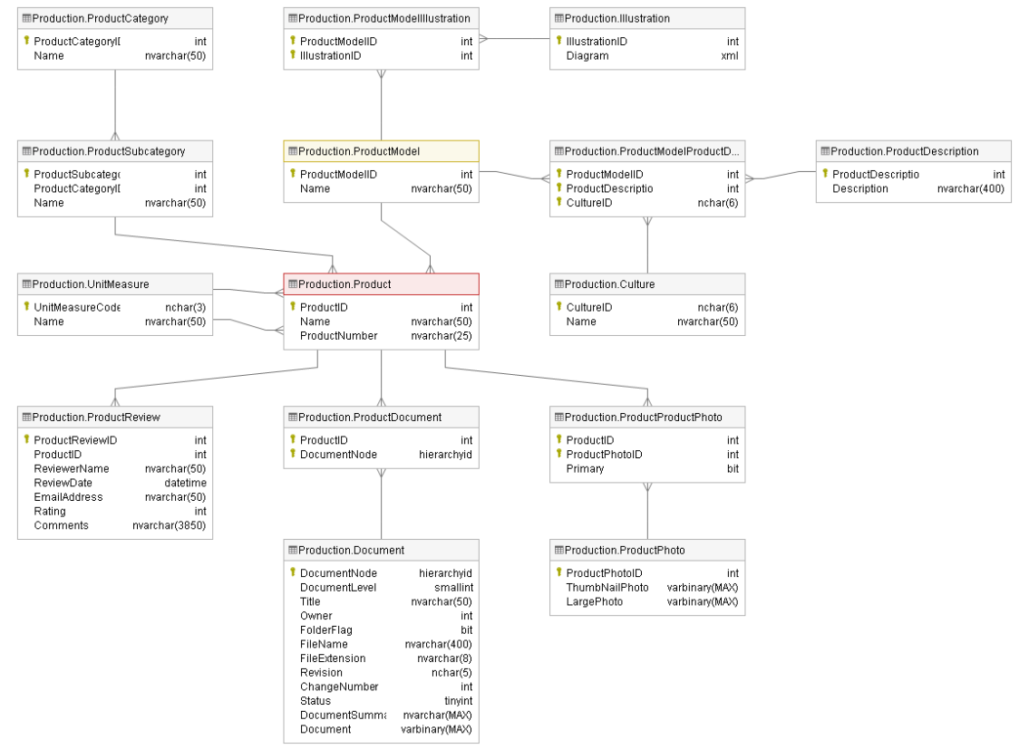

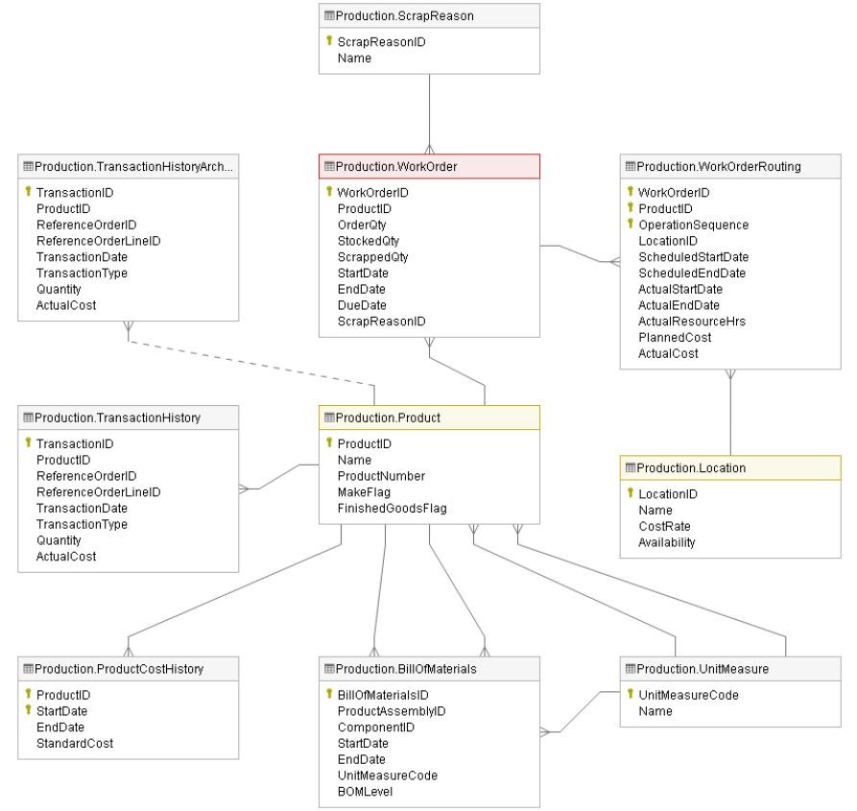

Schema of production is very informative with data on products, manufacturing and inventory. However, utilization of the whole data is not optimal for the project so that a number of data fields could be left out and the rest that is helpful will be useful for the further steps.

Apart from the plus points, there are some clear-cut drawbacks. Despite the version of the year 2019, data time is between 2011 and 2014, meaning that the gap of time is too long. The project can be carried out but its accuracy may be undefined. Another limitation is that some data fields are ambiguous in explanation from AdventureWorks Data Dictionary. It would be confusing if the business process is not well understood.

## 3.3. Business Requirements Analysis

Based on the company’s objective, we identify some of the requirements from Adventure Works as follows:

* The company needs to be able to access the data in one single location and in a format that can be easily manipulated.
* The system will be able to display figures and charts that are clear, intuitive, and user-friendly.
* The business wants to have a holistic picture of the production performance and inventory status. So they require the dashboard to display some key metrics and KPI.
* They also likes to see some analysis of trends or patterns of data to help them plan, and control risks, as well as make a more reasonable production schedule.

## 3.4. IT requirements Analysis (IT & Infrastructure)

Based on the existing IT infrastructure available in the company, Adventure Works intends to use SQL Server Management Studio (SSMS) and SQL Server Data Tools (SSDT) and SSAS (SQL Server Analysis Services) for developing the BI solution. In addition, they also want to use Microsoft Power BI to generate self-servicing reports because Power BI is quite easy to use even for non IT experts so that top and middle level management are able to explore the business data their own on demand BI reports without reliance on the IT department.

## 3.5 Comparative Analysis of BI and Data Visualization Tools

### 3.5.1 Surveying and evaluation

As regards BI tools, it is important to choose a suitable tool. Power BI and Tableau are considered for the project.

Power BI is developed by Microsoft with primary focus on business intelligence. It is part of the Microsoft Power Platform and is a collection of software services, apps, and connectors that are able to work together to turn unrelated sources of data into coherent, visually immersive and interactive insights. Data may be input directly from a database, webpage, or structured files such as spreadsheets, CSV, XML, and JSON. Similarly, Tableau provides a powerful and fast growing data visualization tool for business intelligence. It enables simplifying raw data in an easily understandable format.

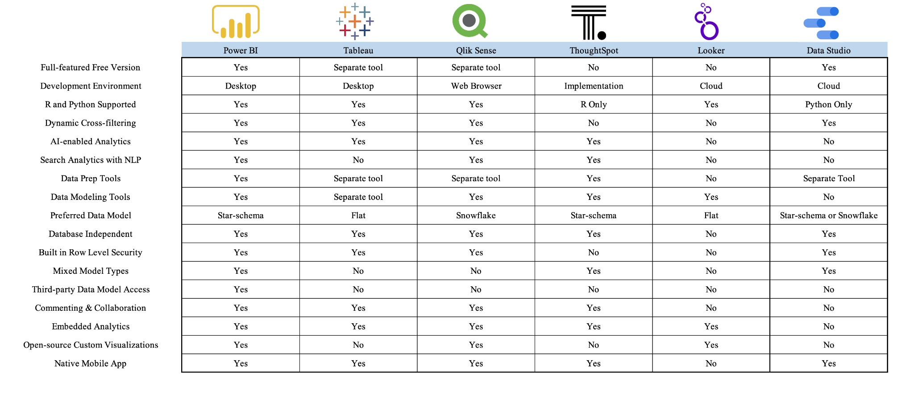

Comparison of PowerBI and Tableau

Both of them have advantages and disadvantages themselves. However, Power BI is more appropriate owing to its features that meet the project requirements.

### 3.5.2 Proposing BI solution for the project

There are a variety of ways for implementing a BI solution. This may vary significantly depending on the company's size and finances. In this case, we propose the project will go through five phases:

* Define the requirements
* Collect the data
* Clean the data
* Analyze the data
* Visualize and share findings

Define the requirements

The team will identify the requirements from stakeholders and validate the data needed to achieve business objectives as well as establish the KPIs required to be measured. This phase is very important because it forms the foundation for the next phases.

Collect the data

Once the requirements are gathered and objectives are set, we then source the data and transform it into a form that will provide the required intelligence to the users. It is important to identify the data available in the source that can meet the project objectives. As mentioned earlier, the source business data is stored in the form of a relational database using the SQL server. Based on the project requirement, it was decided that the data from the source would be transformed and stored into a data warehouse. One of the most commonly used techniques for designing a data warehouse is dimensional modeling (Kimball and Ross, 2013). We will follow Kimball’s four steps to dimensional modeling:

* Select the business process.
* Declare the grain.
* Identify the dimensions.
* Identify the facts.

Clean the data

In this step, we will eliminate bad data ([redundant](https://www.talend.com/resources/what-is-data-redundancy/), incomplete, or incorrect data) and begin to create high-quality data for the best business intelligence.

Analyze the data

Data that is processed, organized and cleaned would be ready for the analysis. In this phase, we will apply some type of analysis such as

* Descriptive analysis to identify what has already happened
* Diagnostic analytics to understand why something has happened and help the company draw correlations between the issue and factors that might be causing it

Visualize and share findings

The final phase is sharing the insights that we have found in the previous phase. To present it clearly and unambiguously, we use reports, dashboards, and interactive visualizations. Nowadays, there are many tools for data visualization but we will choose Power BI desktop version as mentioned before.

# CHAPTER 4: BUILDING DATA WAREHOUSE AND INTEGRATING DATA

## Introduction

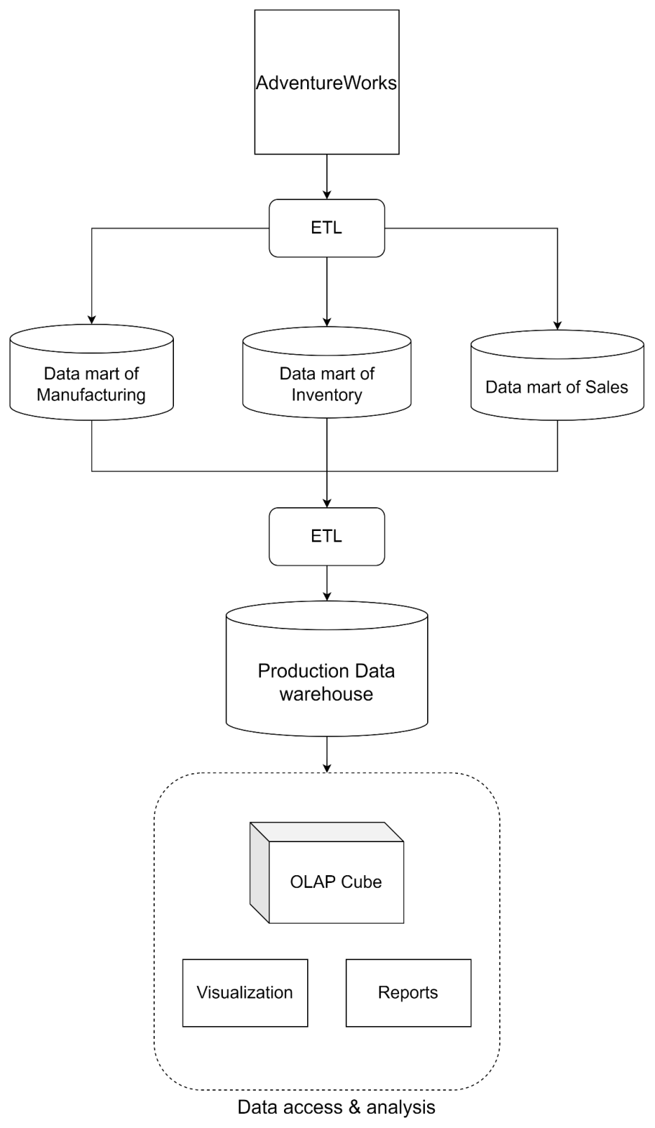

Research process of the project

As chosen approach was Kimball’s, we conducts ETL process to gather the data from AdventureWorks. Then, data marts are designed and built with fact and dimensional tables based on the subject of the research. After that, data fields are extracted, transformed into suitable type. Loading data is carried out with SQL Server Integration Services to combine all data marts into a data warehouse. After gather enough data for the project, analytics are performed with OLAP, visualization and reports in order to help managers make decisions better and more quickly.

## 4.1. Designing Data Warehouse

### 4.1.1. Bus Matrix

|  |  |  |  |  |  |  |
| --- | --- | --- | --- | --- | --- | --- |
|  | Date | Product | Work order | Routing | Scrap | Location |
| Production | x | x |  |  |  |  |
| Scheduling | x | x | x | x |  |  |
| Quality checking | x | x |  |  | x |  |
| Work planning | x | x | x | x |  |  |
| Inventory | x | x |  |  |  | x |

Bus Matrix table

### 4.1.2 Master Data

Master data is defined by a few central characteristics that distinguish it from transaction data in particular: It has a high level of statistics, which means that it rarely changes and is mostly valid in the long term. Since master data is used by several divisions of a company, it is highly relevant for all business processes.

Our master data is the data used to build the Dimension tables in the data warehouse, including the tables:

|  |  |
| --- | --- |
| **Object** | **Description** |
| Product | Products sold or used in the manufacturing of sold products. |
| ProductSubCategory | Product subcategories. |
| ProductCategory | High-level product categorization. |
| Location | Product inventory and manufacturing locations. |
| ScrapReason | Manufacturing failure reasons lookup table. |

### 4.1.3 Transaction Data

Transaction data relates to the transactions of the organization and includes data that is captured. It is also used to construct fact tables in the data warehouse, including tables:

|  |  |
| --- | --- |
| **Object** | **Description** |
| WorkOrder | Manufacturing work orders. Details of each production order, represented by specific products, required quantity, stocked quantity, scrapped quantity, start date, end date and due date of work order. |
| WorkOrderRouting | Contains detailed data about production processes, transactions displayed in order of the production process,  planned start and end dates, actual start and end dates, hours production used, estimates and actual production costs at  specific times. |
| ProductInventory | Product inventory information. The transaction data is displayed for each product in an amount, in any location,  shelf and bin |

### 4.1.4. Fact and dimension tables

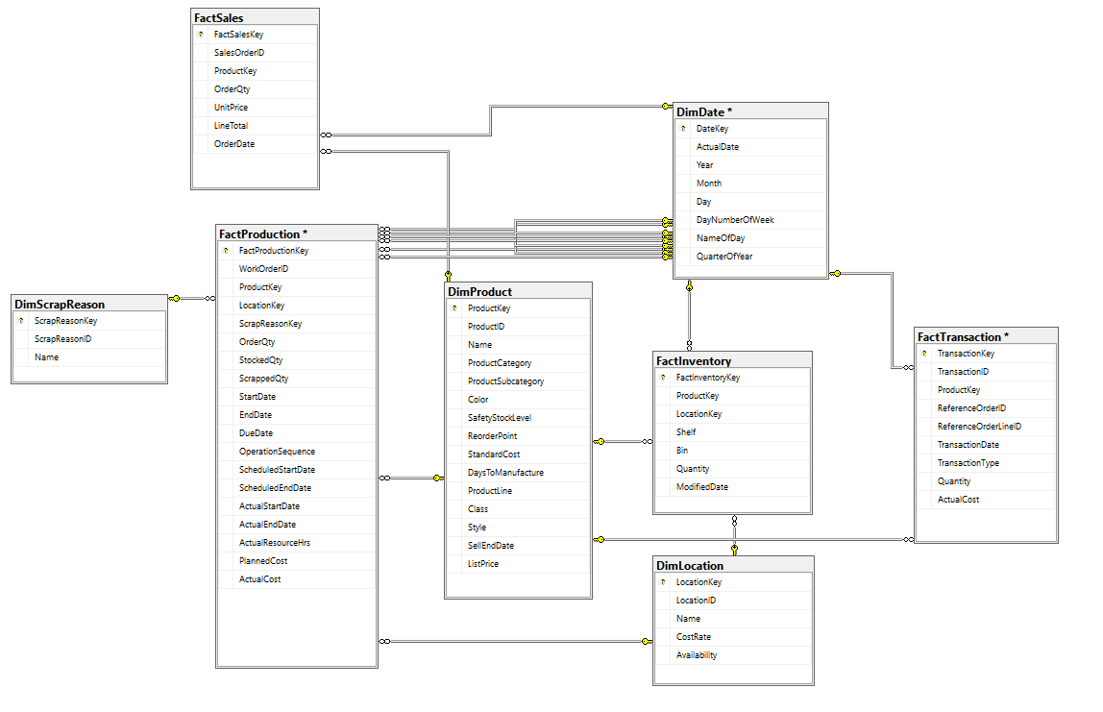

Data model

The figure shows the data warehouse model which contains two data marts (Production and Inventory). We have five dimensional tables and two fact tables. Below is a detailed description for each of them.

**FactProduction table** contains information about manufacturing work orders and work order details

|  |  |  |  |  |
| --- | --- | --- | --- | --- |
|  | Column Name | Data type | Nullable | Description |
| PK | ProductionKey | int |  | Primary key for production fact table.  Auto increment column |
| FK | FactProductKey | int |  | Product identification number. Foreign key to DimProduct.ProductKey |
| FK | LocationKey | int | N | Location identification number. Foreign key to DimLocation.LocationKey |
| FK | ScrapReasonKey | int | N | ScrapReason identification number. Foreign key to DimScrapReason.ScrapReasonKey |
|  | WorkOrderID | int |  | Identity for WorkOrder records. |
|  | OrderQty | int |  | Product quantity need to build. |
|  | StockedQty | int |  | Quantity built and put in inventory.  Computed: isnull([OrderQty]-[ScrappedQty],(0)) |
|  | ScrappedQty | smallint |  | Quantity that failed inspection |
| FK | StartDate | int |  | Work order start date. |
| FK | EndDate | int |  | Work order end date. |
| FK | DueDate | int |  | Work order due date. |
|  | OperationSequence | smallint |  | Indicates the manufacturing process sequence. |
| FK | ScheduledStartDate | int |  | Planned manufacturing start date. |
| FK | ScheduledEndDate | int |  | Planned manufacturing end date. |
| FK | ActualStartDate | int | N | Actual start date. |
| FK | ActualEndDate | int | N | Actual end date. |
| FK | ActualResourceHrs | decimal(9, 4) | N | Number of manufacturing hours used. |
|  | PlannedCost | money |  | Estimated manufacturing cost. |
|  | ActualCost | money | N | Actual manufacturing cost. |

FactProduction table

**FactInventory:** storages inventory description includes storage compartment, storage container, and quantity of products in the inventory location

|  |  |  |  |  |
| --- | --- | --- | --- | --- |
|  | Column | Data Type | Nullable | Description |
| PK | InventoryKey | int |  | Primary key for DimInventory table. Autoincrement column |
| FK | ProductKey | int |  |  |
| FK | LocationKey | int |  |  |
|  | Shelf | nvarchar(10) |  | Storage compartment within an inventory location. |
|  | Bin | tinyint |  | Storage container on a shelf in an inventory location. |
|  | Quantity | smallint |  | Quantity of products in the inventory location. |
| FK | ModifiedDate | int |  | Date and time the record was last updated. Default: getdate() |

FactInventory table

**FactTransaction table** contains information about product transaction history and Transaction history archive.

|  |  |  |  |  |
| --- | --- | --- | --- | --- |
|  | Column | Data Type | Nullable | Description |
| PK | TransactionKey | int |  | Primary key for Transaction fact table.  Auto increment column |
|  | TransactionID | int |  | Purchase order, sales order, or work order identification number. |
| FK | ProductKey | int |  |  |
|  | ReferenceOrderID | int |  | Purchase order, sales order, or work order identification number. |
|  | ReferenceOrderLineID | int |  | Line number associated with the purchase order, sales order, or work order. |
| FK | TransactionDate | int |  | Date and time of the transaction |
|  | TransactionType | nchar(1) |  | W = Work Order, S = Sales Order, P = Purchase Order |
|  | Quantity | int |  | Product quantity. |
|  | ActualCost | money |  | Product cost. |

FactTransaction table

**FactSale table** contains information about Sale order detail.

|  |  |  |  |  |
| --- | --- | --- | --- | --- |
|  | Column | Data Type | Nullable | Description |
| PK | FactSalesKey | int |  | Primary key for Sale fact table.  Auto increment column |
|  | SalesOrderID | int |  |  |
| FK | ProductKey | int |  |  |
|  | OrderQty | smallint |  | Quantity ordered per product. |
|  | UnitPrice | money |  | Selling price of a single product. |
|  | LineTotal | numeric(38, 6) |  | Per product subtotal. |
| FK | OrderDate | int |  | Dates the sales order was created |

FactSale table

**DimDate** includes the format of date so that we can visualize facts and figures over the time in the calendar. In this table, we use the data of Year, Month, Day, DayNumberOfWeek, NameOfDay, QuarterOfYear to be easily statistical and intuitive guarantee in data mining. The PK_Date format is automatically saved from the fact table.

|  |  |  |  |  |
| --- | --- | --- | --- | --- |
|  | Column Name | Data type | Nullable | Description |
| PK | DateKey | int |  | Primary key for Date Dimension table.  Auto increment column |
|  | ActualDate | int |  |  |
|  | Year | int |  |  |
|  | Month | int |  |  |
|  | Day | int |  |  |
|  | DayNumberOfWeek | int |  | Example: Sunday is 1, Monday is 2 and so on |
|  | NameOfDay | int |  | Example: Monday, Tuesday |
|  | QuarterOfYear | int |  |  |

DimDate table

**DimScrapReason:** contains the scrap reasons of product. Using the information in this table can help us sort, statistics the amount of excess or broken goods.

|  |  |  |  |  |
| --- | --- | --- | --- | --- |
|  | Column Name | Data type | Nullable | Description |
| PK | ScrapReasonKey | int |  | Primary key for Scrap Reason Dimension table.  Auto increment column |
| FK | ScrapReasonID | smallint |  | Scrap reason identification number |
|  | Name | nvarchar(50) |  | Failure description. |

DimScrapReason table

**DimProduct** storages product information sold or used in the manufacturing of sold products.

|  |  |  |  |  |
| --- | --- | --- | --- | --- |
|  | Column Name | Data type | Nullable | Description |
| PK | Product Key | int |  | Primary key for Product Dimension table.  Autoincrement column |
|  | ProductID | int |  | Product identification number |
|  | Name | nvarchar(50) |  | Name of the product. |
|  | ProductCategory | nvarchar(50) |  | Category description. |
|  | ProductSubcategory | nvarchar(50) |  | Subcategory description. |
|  | Color | nvarchar(15) | N | Product color. |
|  | SafetyStockLevel | smallint |  | Minimum inventory quantity |
|  | ReorderPoint | smallint |  | Inventory level that triggers a purchase order or work order |
|  | StandardCost | money |  | Standard cost of the product |
|  | DaysToManufacture | int |  | Number of days required to manufacture the product |
|  | ProductLine | nchar(2) |  | 4 lines: R = Road, M = Mountain, T = Touring, S = Standard |
|  | Class | nchar(2) | N | 3 classes: H = High, M = Medium, L = Low |
|  | Style | nchar(2) | N | 3 styles: W = Womens, M = Mens, U = Universal |
|  | SellEndDate | int | N | Date the product was no longer available for sale. |
|  | ListPrice | money |  | Selling price |

DimProduct table

**DimLocation:** storages inventory location and location description include cost and the availability of them.

|  |  |  |  |  |
| --- | --- | --- | --- | --- |
|  | Column | Data Type | Nullable | Description |
| PK | LocationKey | int |  | Primary key for DimLocation table. Autoincrement column |
|  | LocationID | smallint |  | Inventory location identification number. |
|  | Name | nvarchar(50) |  | Location description |
|  | CostRate | smallmoney |  | Standard hourly cost of the manufacturing location |
|  | Availability | decimal(8,2) |  | Work capacity (in hours) of the manufacturing location |

DimLocation table

## 4.2. ETL processes

After defining the data warehouse model, the next step we need to perform is populating data warehouse. The tools to transfer data from the source table to the target table we used is SSIS - a platform for data integration and workflow applications.

### 4.2.1. Dimension Table’s ETL Process

Each dimension table will have

* The primary key (surrogate key): This is an identity (1,1) column, and the values are unique. It joins with the foreign key in the fact table and allows to connect those two tables to ensure the integrity. It has no business meaning and used to maintain a hierarchy.
* The natural key (domain key): A descriptor of the data. It is based on attributes that exist. The relationship of the surrogate key and natural key may be one o one or many to one (in slowly changing dimension)
* Descriptive attributes (textual, numeric): describes a non-unique characteristic of an entity instance

Besides, dimension tables have the similar ETL process using Slowly Changing Dimension to store and manage both current and historical data over time in a data warehouse.

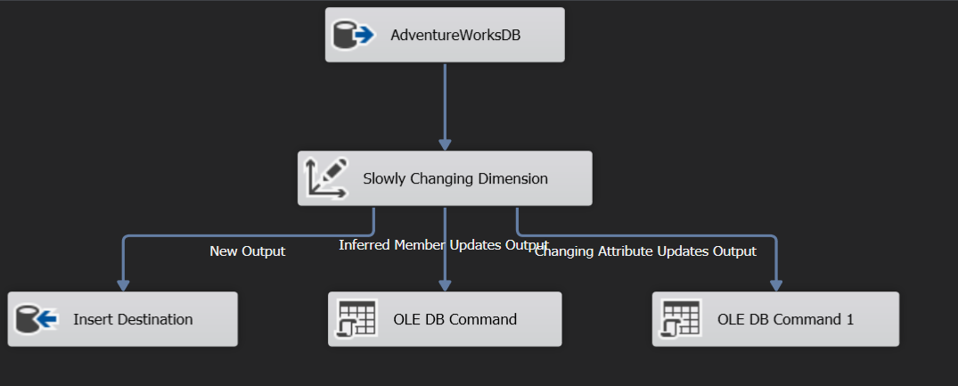  
Data task flow of dimension tables

#### 4.2.1.1. DimProduct Table

Initially, in AdventureWorks database, we built a DimProductTemp table to get attributes and their data types. Then in data warehouse ProductionDW, we created a DimProduct table with the same design as the DimProductTemp. We added the surrogate key as the primary key of the table, they are unique and not null.

Below is the query we used to build “DimProductTemp” table:

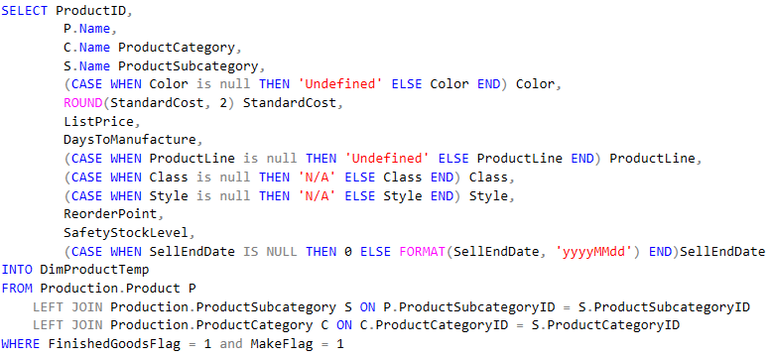

Design of DimProduct table:

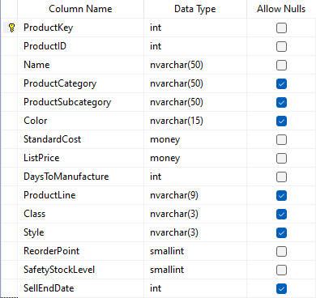

Data designing of DimProduct table

After running we have the result:

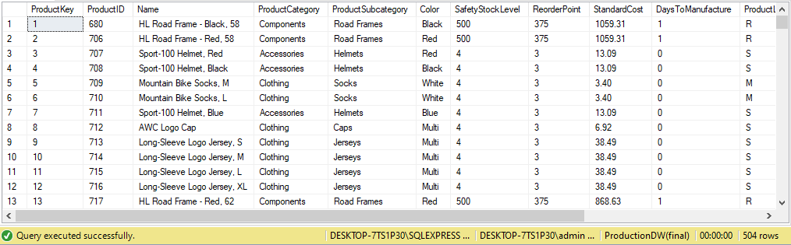

Data of DimProduct table

#### 4.2.1.2. DimLocation Table

Initially, we built a DimLocationTemp table to get attributes and their data types. We then designed a DimLocation table in our data warehouse called ProductionDW with the same design as the DimLocationTemp.

Query to build “DimLocationTemp” table in AdventureWorks database:

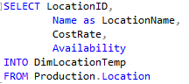

Design of DimLocation:

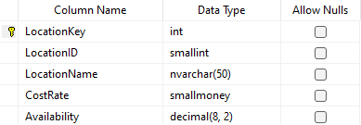

Data designing of DimLocation table

After running we have the result:

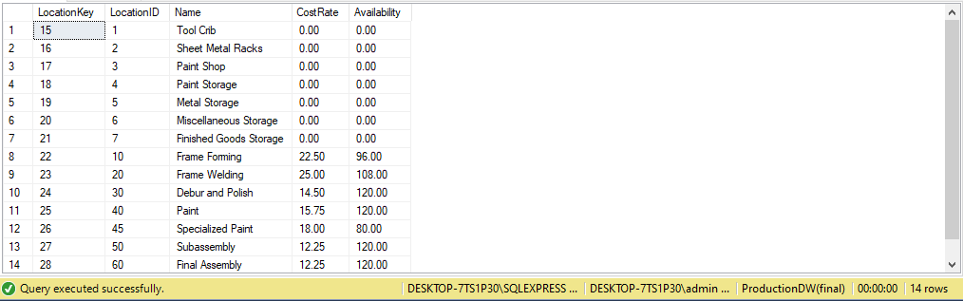

Data of DimLocation table

#### 4.2.1.3. DimScrapReason Table

Initially, we built a DimScrapReasonTemp table to get attributes and their data types. We then designed a DimLocation table in our database called ProductionDW with the same design as the DimScrapReasonTemp.

Design DimScrapReasonTemp table in AdventureWorks database based on the query:

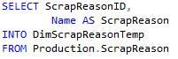

Design of DimScrapReason table

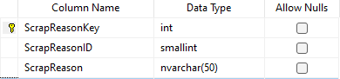

Data designing of DimScrapReason table

After running, we have the result:

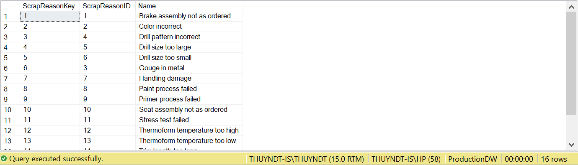

Data of DimScrapReason table

4.2.1.3. DimDate Table

There are many ways to create a date dimension table. In this case, we will use Analysis Services Multidimensional and Data Mining Project to create a DimTimeTemp table.

Dimension structure of DimTimeTemp:

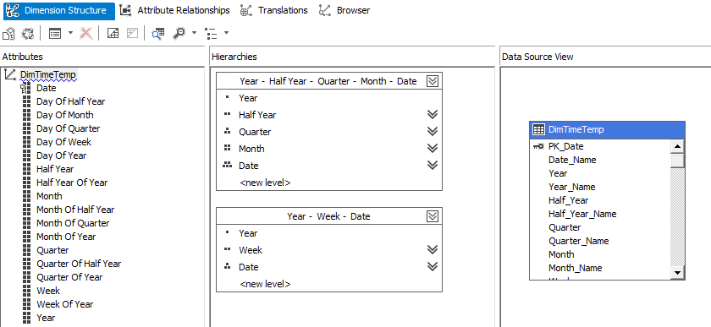

Dimension structure of DimTimeTemp

After running, we have the result of DimTimeTemp:

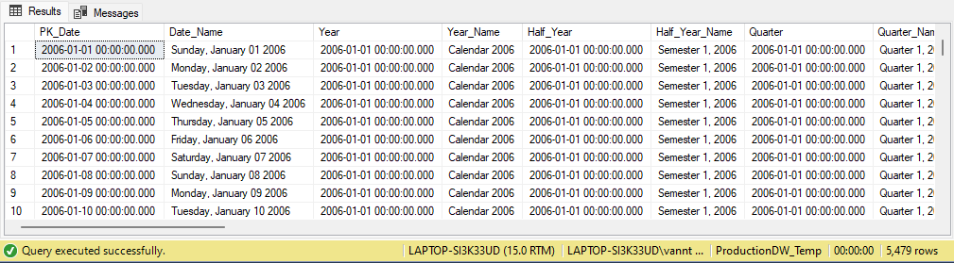

Data of DimTimeTemp table

Then, based on DimTimeTemp we create a DimDate that is suitable for our project. Below is the query:

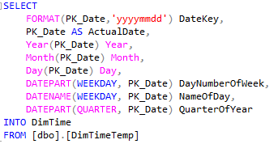

The result of DimDate:

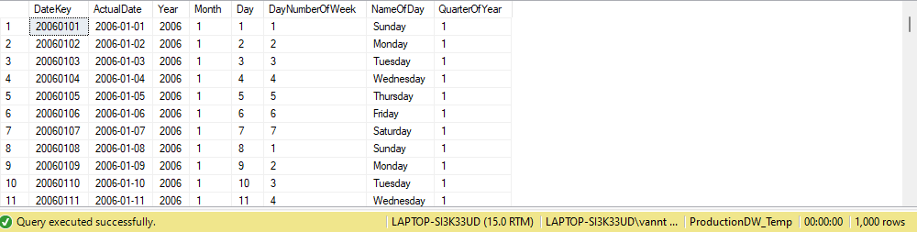

Data of DimDate table

### 4.2.2. Fact Table’s ETL Process

#### 4.2.2.1 Table FactProduction

Table FactProduction is extracted and transformed with SSMS and then loaded with SSIS. Below is the data task flow loading data from AdventureWorks into data warehouse. FactProduction is lookup with ProductKey, LocationKey, ReasonKey in that order.

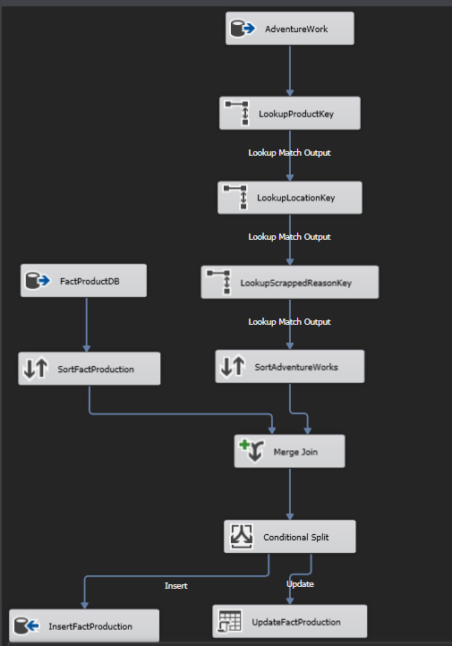

Data flow task of FactProduction

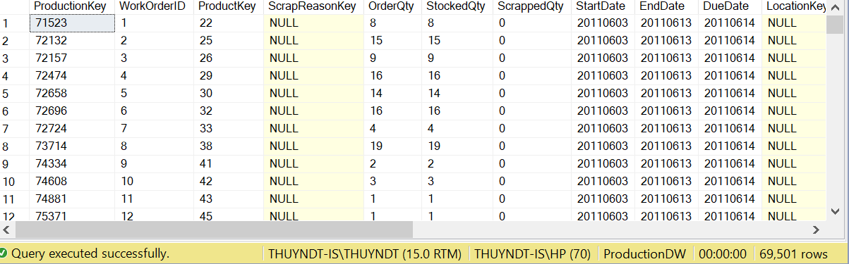

Data of FactProduction

#### 4.2.2.2 Table FactInventory

Similarly, data from FactInventory is loaded. However, some errors have come into view so that the data warehouse is not loaded as we expected.

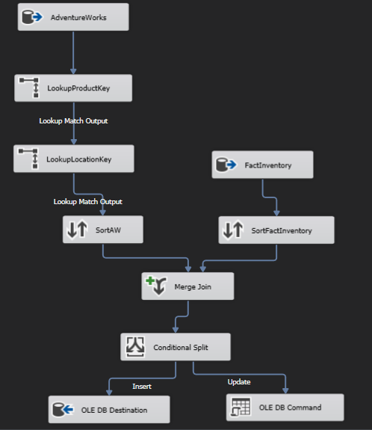Data flow task of FactInventory

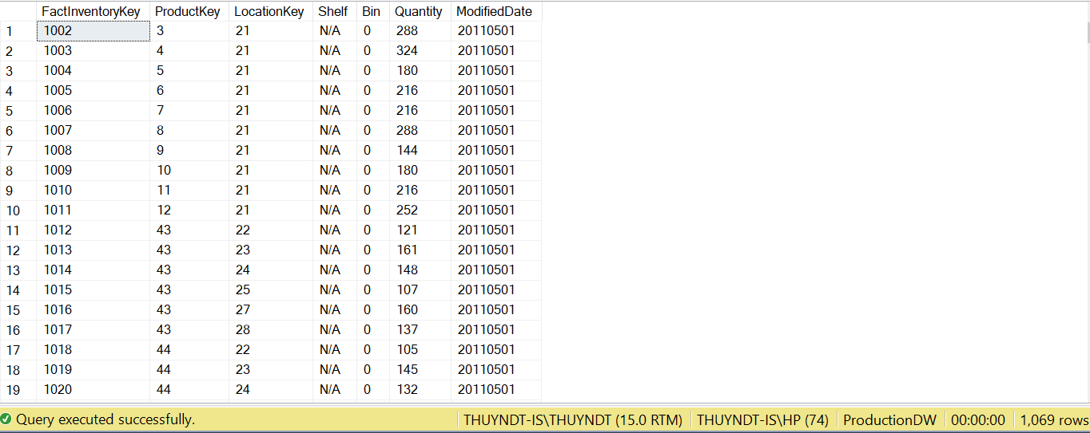

Data of FactInventory

#### 4.2.2.3 Table FactTransaction

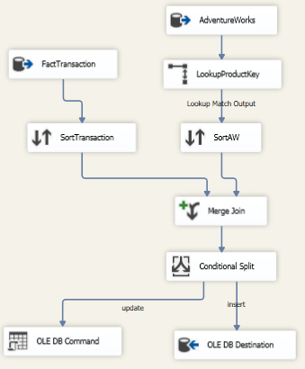

Data flow task of FactTransaction

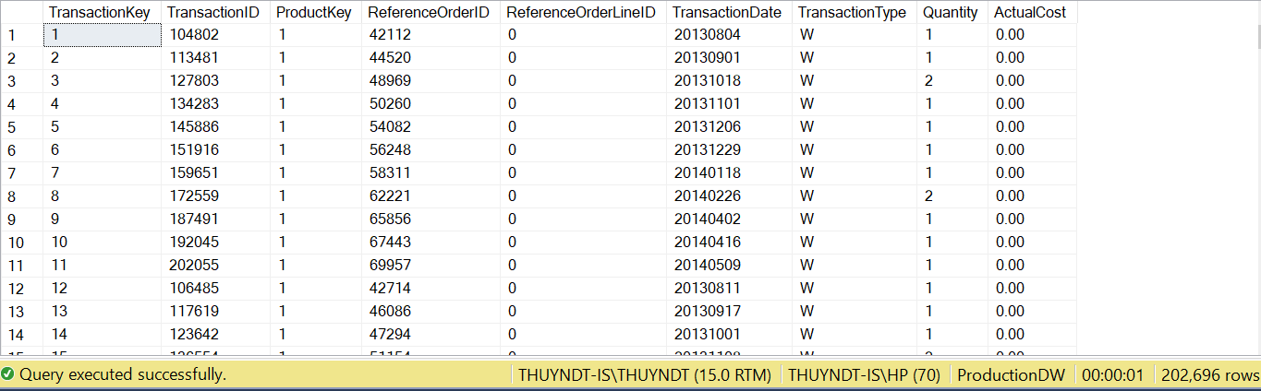Data of FactTransaction

#### 4.2.3.4 Table FactSales

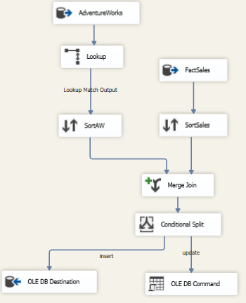

Data flow task of FactSales

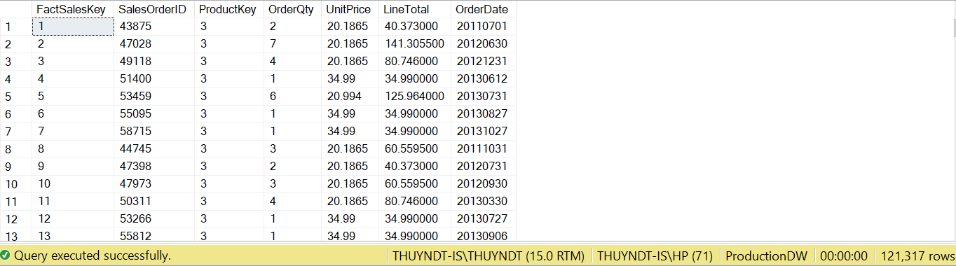Data of FactSales

# CHAPTER 5: DATA ANALYTICS

# 5.1. Data analytics with SSAS technology

We utilize SSAS technology (SQL Server Analysis Service) to build a cube and analyze data from data warehouse “ProductionDW”.

There are 5 steps to implement an Analysis Services database. Below is a detailed description for each step.

**Step 1: Create a data source**

Firstly, we created an Analysis Services project in SQL Server 2019 Business Intelligence Development Studio and named the project “ProductionDW_SSAS”.

Then, we connect the project to the ProductionDW sample data warehouse on a local instance of SQL Server 2019.

After setting up the connection, we configure the impersonation information as the figure below

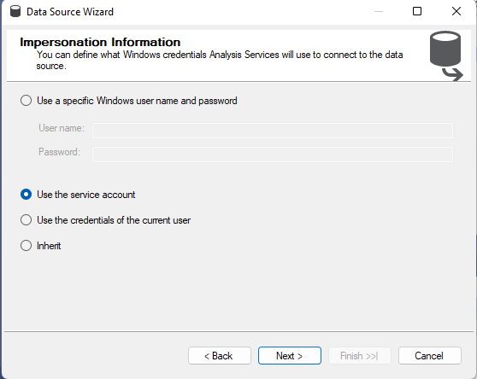

Impersonation information

After that, data sources connected successfully.

**Step 2: Create a data source view**

For the purposes of this project, we selected four fact tables (FactInventory, FactProduction, FactSales and FactTransaction) and four dimension tables (DimLocation, DimDate, DimProduct and DimScrapReason)

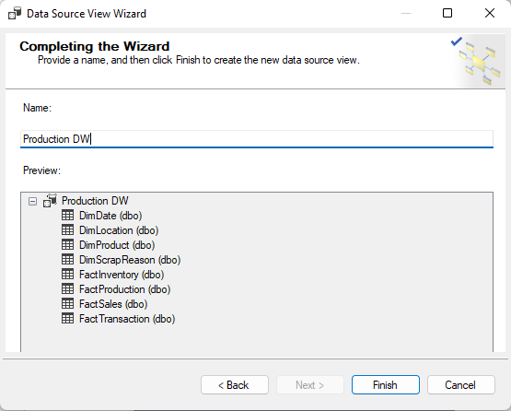

Data source view wizard

After clicking the Finish button, SQL Server Analysis Services creates the data source view and opens a window in the design surface that displays a detailed view, as shown in the figure.

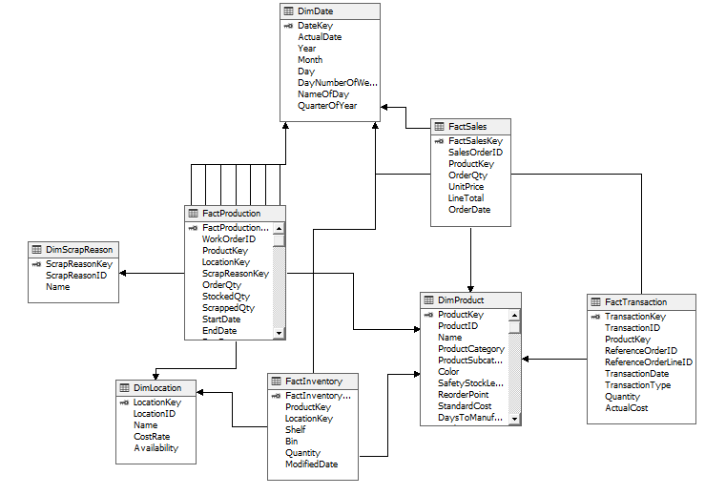

Data warehouse view

**Step 3: Create a cube**

From the data source view, we build a cube that is a multi-dimensional data source which has four fact tables, including: FactInventory, FactProduction, FactSales and FactTransaction. Each table is a measure group table. Measure groups are used to associate dimensions with measures.

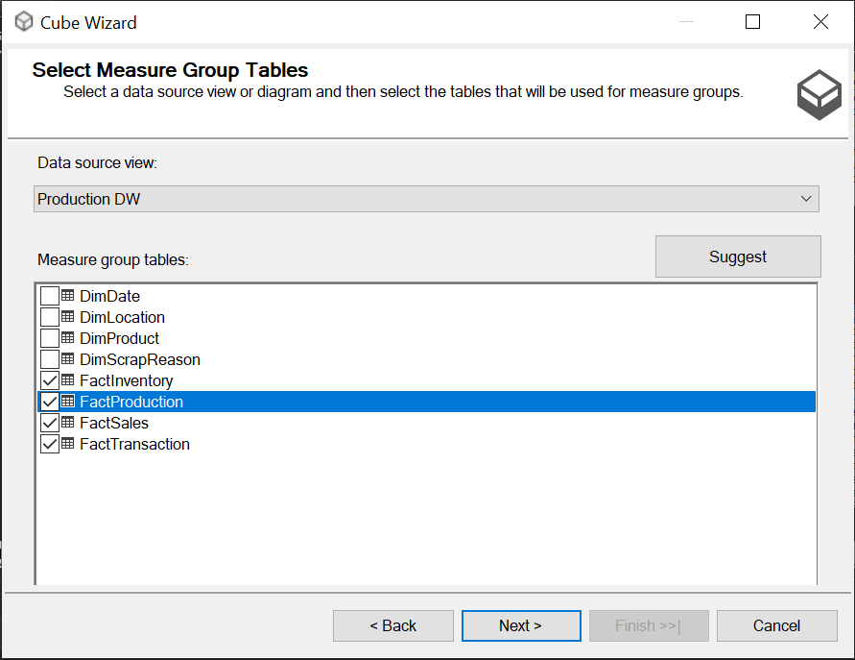

Fact tables in cube

Continue, we select measures that contain quantifiable data, details are as follow:

* From FactSales: OrderQuantity, UnitPrice, LineTotal.
* From FactTransaction: Quantity, ActualCost.
* From FactInventory: Quantity.
* From FactProduction: OrderQuantity, StockedQuantity, ScrappedQuantity, ActualResourceHrs, PlannedCost.

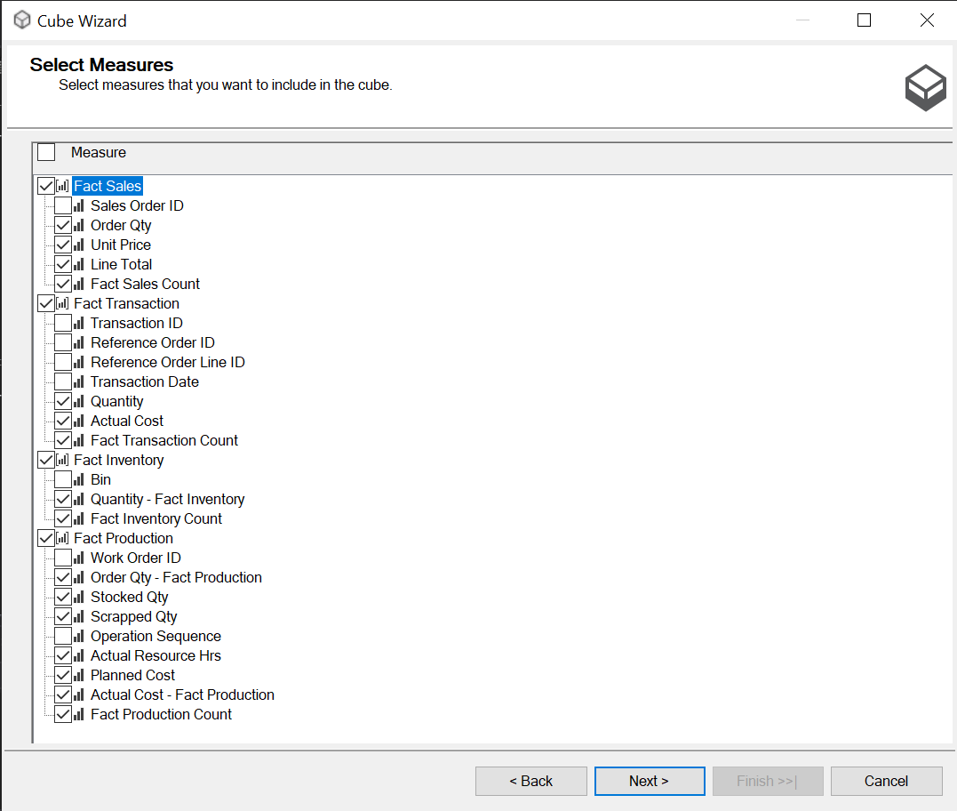

Measures included in the cube

Next, we pick dimension tables to include in the cube: DimProduct, DimDate, DimLocation, DimScrapReason.

When completing the wizard, SQL Server Analysis Services will generate the cube and open it in the designer surface. The figure below shows the Cube Designer for the Production DW project.

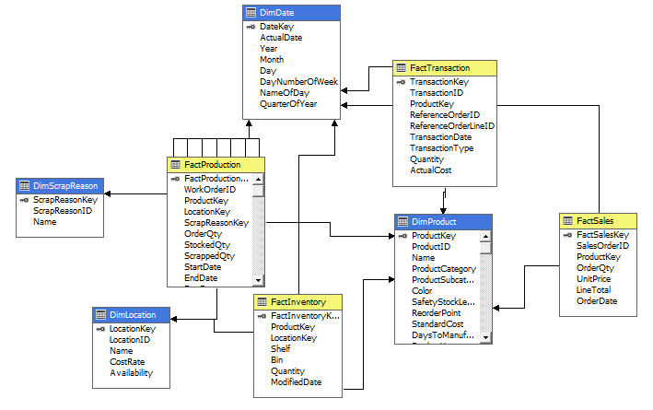

Figure: The ProductionDW cube in Cube Designer

**Step 4: Edit Dimension**

The next step is to specify the attributes to include in the dimension tables. We double click on the name of dimension, then select every attributes that are suitable for the project, and drag the selected properties from the Data Source View to Attributes. Figures below show the attributes we have selected for every dimension.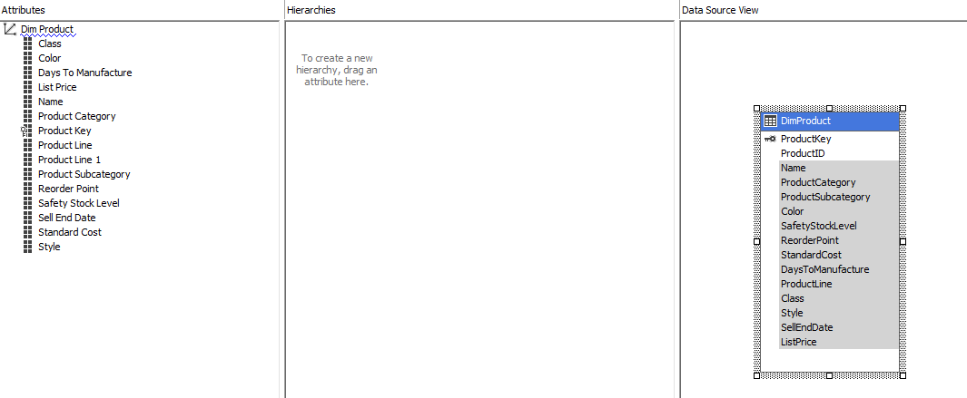 Dimension Structure of DimProduct

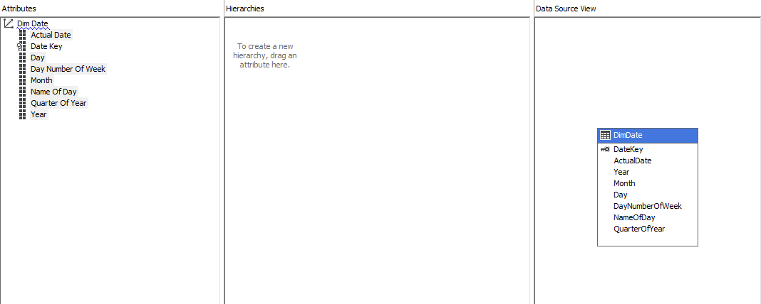

Dimension Structure of DimDate

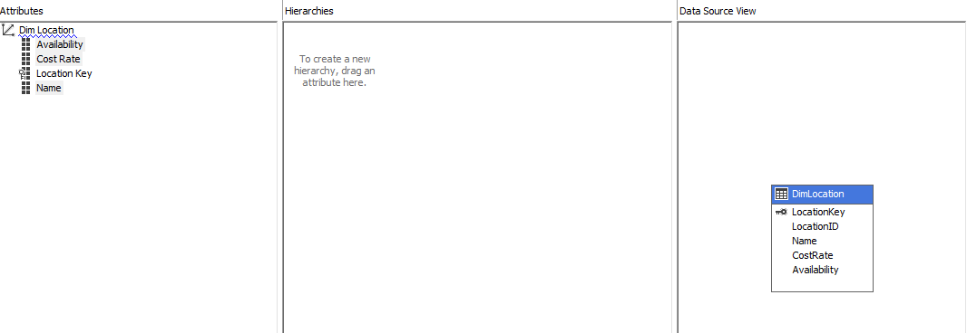

Dimension Structure of DimLocation

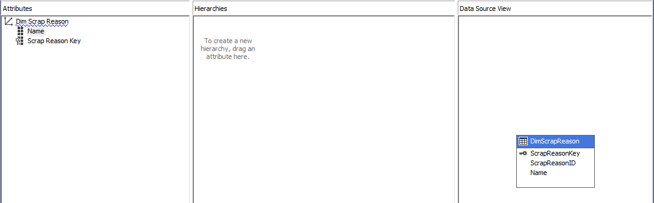

Dimension Structure of DimScrapReason

**Step 5: Deploy the database**

The final step is to deploy the database to the SQL Server instance. Right-click the project name in Solution Explorer, and then click Deploy. The database is deployed with no problems, we receive a message saying that the deployment is complete.

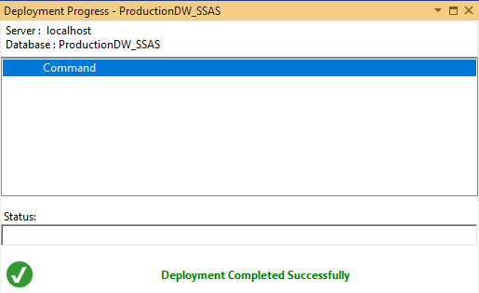

Deployment Completed Successfully

### 5.1.3. Building KPIs system with SSAS

#### 5.1.3.1 Production Volume

Production volume measures the total amount your company can produce over time. This KPI tracks the total number of products manufactured over a set period of time and focuses on total output.

**KPI name:** KPIManufacturingQuantity

**Value expression:** [Measures].[Stocked Qty]

Goal expression:

CASE WHEN [Dim Product].[Product Category] IS [Dim Product].[Product Category].&[Bikes] THEN 40000

WHEN [Dim Product].[Product Category] IS [Dim Product].[Product Category].&[Components] THEN 200000

WHEN [Dim Product].[Product Category] IS [Dim Product].[Product Category].&[Accessories] THEN 0

WHEN [Dim Product].[Product Category] IS [Dim Product].[Product Category].&[Clothing] THEN 0

END

Status expression

CASE

WHEN KPIVALUE('KPIManufacturingQuantity')/KPIGOAL('KPIManufacturingQuantity') > 0.7 THEN 1

WHEN KPIVALUE('KPIManufacturingQuantity')/KPIGOAL('KPIManufacturingQuantity') <= 0.7 THEN -1

END

Trend expression

CASE

WHEN ISEMPTY(PARALLELPERIOD([End Date].[Year].[Year],1,[End

Date].[Year]))THEN 0

WHEN [Measures].[Stocked Qty] > (PARALLELPERIOD([End Date].[Year].[Year], 1, [End Date].[Year].currentmember),[Measures].[Stocked Qty]) THEN 1

WHEN [Measures].[Stocked Qty] = (PARALLELPERIOD([End Date].[Year].[Year], 1, [End Date].[Year].currentmember), [Measures].[Stocked Qty]) THEN 0

ELSE -1

END

Results:

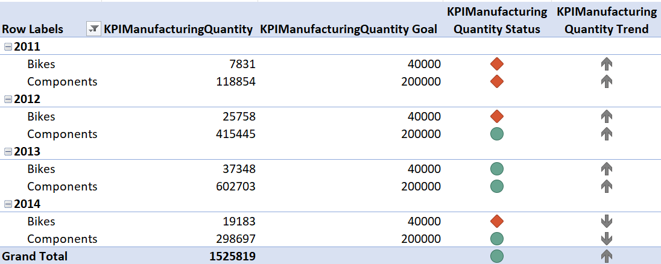

Manufacturing quantity KPI

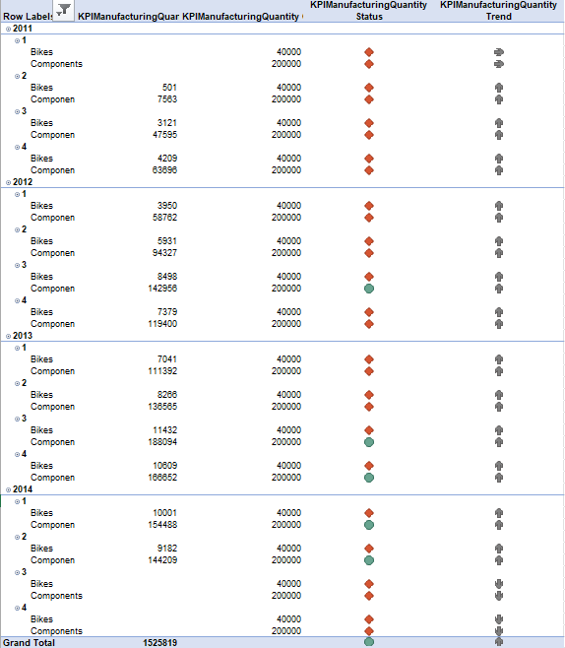

Manufacturing cost KPI

We set the KPIs for each product category as follows:

Bikes: 40,000$ and Components: 200,000$

Looking at the table, we can see that bikes are often below the goal (except for 2013), while components have a better result, it exceeds the goal 3 years in a row (2011, 2012, 2013).

When it comes to trend, manufacturing volume in 2012 and 2013 both higher than the previous year. But in 2014, we just have the data for the first 6 months so we cannot know that the trend is actually decreasing or increasing.

#### 5.1.3.2 Manufacturing cost

KPI name: KPIManufacturingCost

Value expression: [Measures].[Actual Cost - Fact Production]

Goal expression:

CASE WHEN [Dim Product].[Product Category] IS [Dim Product].[Product Category].&[Bikes] THEN 350000

WHEN [Dim Product].[Product Category] IS [Dim Product].[Product Category].&[Components] THEN 800000

WHEN [Dim Product].[Product Category] IS [Dim Product].[Product Category].&[Accessories] THEN 0

WHEN [Dim Product].[Product Category] IS [Dim Product].[Product Category].&[Clothing] THEN 0

ELSE 0

END

Status expression:

CASE WHEN [Dim Product].[Product Category] IS [Dim Product].[Product Category].&[Bikes] THEN 350000

WHEN [Dim Product].[Product Category] IS [Dim Product].[Product Category].&[Components] THEN 800000

WHEN [Dim Product].[Product Category] IS [Dim Product].[Product Category].&[Accessories] THEN 0

WHEN [Dim Product].[Product Category] IS [Dim Product].[Product Category].&[Clothing] THEN 0

ELSE 0

END

Trend:

CASE

WHEN ISEMPTY(PARALLELPERIOD([End Date].[Year].[Year],1,[End

Date].[Year]))THEN 0

WHEN [Measures].[StandardCostInventory] > (PARALLELPERIOD([End Date].[Year].[Year], 1, [End Date].[Year].currentmember), [Measures].[StandardCostInventory]) THEN 1

WHEN [Measures].[StandardCostInventory] = (PARALLELPERIOD([End Date].[Year].[Year], 1, [End Date].[Year].currentmember), [Measures].[StandardCostInventory]) THEN 0

ELSE -1

END

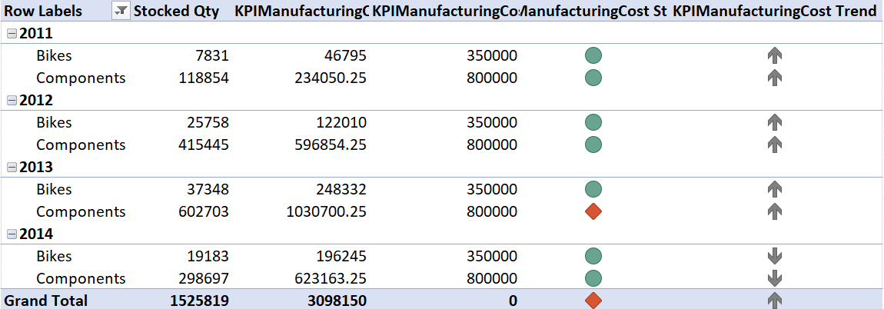

Manufacturing cost KPI

Manufacturing cost KPI will show us the trend and status of manufacturing costs over 4 years (2011 to 2014). We set the KPIs for each product category as follows:

Bikes: 350000$ and Components: 800000$

In terms of status, the results show that in 2011 and 2012 both Bikes and Components products ensure that the cost does not exceed the KPI (it means that the production costs for the categories are lower than the target). However, by 2013, the production of Components had exceeded the cost (1030700.25$ > 800000$), causing the status to exceed the target. By the next year (2014), production costs were low again to ensure that they remained below the planned cost.

Regarding the trend of manufacturing cost, almost from 2011 to 2013, the cost tended to increase (especially in 2013 there was a very strong increase in the production of Components), but by 2014 there was a trend of decreasing costs in both categories. The production department should review and manage the status of production to ensure this trend of cost reduction, or a slight increase to remain within the original cost.

#### 5.1.3.3 Scrap Rate

Scrap rate measures the amount of scraped products compared to the total of products produced. It enables the production department to keep track numbers of products which are deemed scrap. Additionally, it provides the company with insight in production run and identifies an inefficient process. The lower the ratio it has, the better manufacturing performs.

Scrap rate = # of Scrap Units / Total # of Units

Calculation: [ScrapRate]

Expression:[Measures].[Scrapped Qty]/[Measures].[Stocked Qty]

KPI name: KPIScrapRate

Value expression: [Measures].[ScrapRate]

Goal Expression:

CASE WHEN [Dim Product].[Product Category] IS [Dim Product].[Product Category].&[Bikes] THEN 0.0015

WHEN [Dim Product].[Product Category] IS [Dim Product].[Product Category].&[Components] THEN 0.002

WHEN [Dim Product].[Product Category] IS [Dim Product].[Product Category].&[Accessories] THEN 0

WHEN [Dim Product].[Product Category] IS [Dim Product].[Product Category].&[Clothing] THEN 0

ELSE 0.001

END

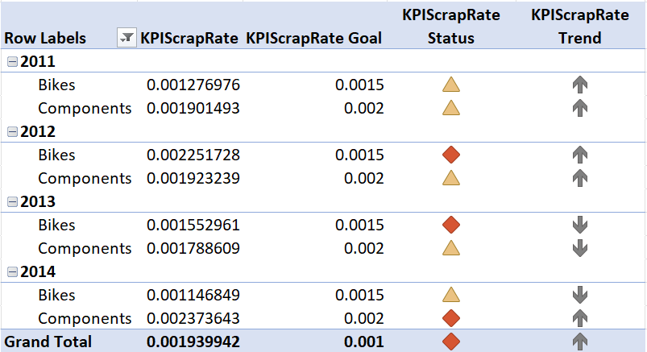

Scrap rate KPI

According to the table above, we see that the product category "Bikes and Components only has yellow and red status, which means that the KPI is not met. Although not meeting the KPI as in 2011, this is a good sign because the actual ScrapRate rate is lower than the ScrapRateGoal KPI, which means that the percentage of broken products appearing is less than expected. However, in 2012, the ScrapRateTrend KPI increased, and the actual ScrapRate of both categories also increased, but the ScrapRate of Bikes exceeded the ScrapRateGoal, i.e., the percentage of damaged goods was higher than expected. This year, the ScrapRate of Components also increased but did not exceed ScrapRateGoal, so it still shows yellow. In 2013, the ScrapRateTrend in two categories began to decline, but the ScrapRate of Bikes continued to exceed the set scrap rate goal. By 2014, the ScrapRateTrend of Bikes decreased, resulting in the ScrapRate of Bikes also falling lower than that of ScrapRateGoal, the error rate during product production in the Bikes category was lower than expected. However, with category Components, ScrapRateTrend increases, ScrapRate shows up in red, which means that the ScrapRateGoal KPI is not reached and in fact exceeded.

# CHAPTER 6: VISUALIZATION AND FORECASTING OR PREDICTIVE MODEL

## 6.1. Data analysis with Power BI

### 6.1.1 Production

#### 6.1.1.1 Production overview

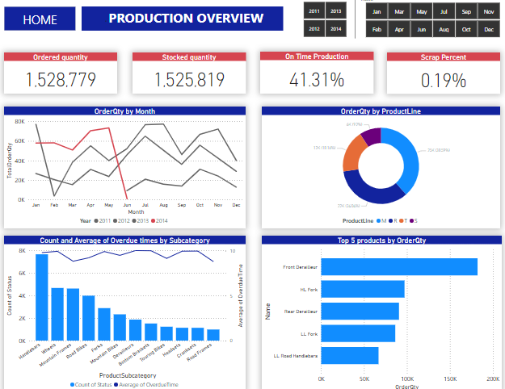

Production overview dashboard

This dashboard shows a general overview about the production status. It consists of four charts: ordered quantity trend, ordered quantity by product line, average of overdue time by product subcategory, and top 5 ordered products. Moreover, we have slicers to let users filter by year and month.

The first section of dashboard are 4 card visuals help the company evaluate operational efficiency of production. As we can see in the dashboard, ordered quantity and stocked quantity are approximately equal to each other, and the scrap rate is quite small (about 0.19%). On the other hand, the percent of time when production goals were met is quite low, just about 41.31%. The reason for this could be the planning is poor, or the work performance is not good. So to mitigate this problem, company should consider some ways to increase productivity at manufacturing such as: Update processes and technology, commit to scheduled maintenance, train and educate employees or organize the workspace,....

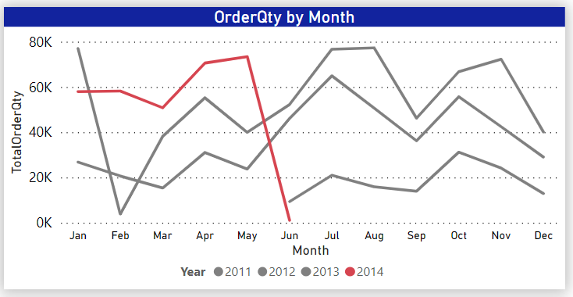

Line chart about ordered quantity

The chart illustrates the total of ordered quantity over the years, which helps managers monitor and compare ordered quantity of the recent year (2014) with the previous years (2011, 2012, 2013), which helps managers monitor and compare ordered quantity of the recent year (2014) with the previous years (2011, 2012, 2013). This chart also show for the managers that order quantity is often high in January, April, July and October while it will be low in February, June, September and December. Based on that, we can predict the trend of or ordered quantity will increase rapidly in the first month of quarter and decrease in the next month, but after that it will increase slightly in the last month. Following this trend, production department will build production planning that maintain amount of product in stock at safety line and in the last month of quarter, we need to promote production.

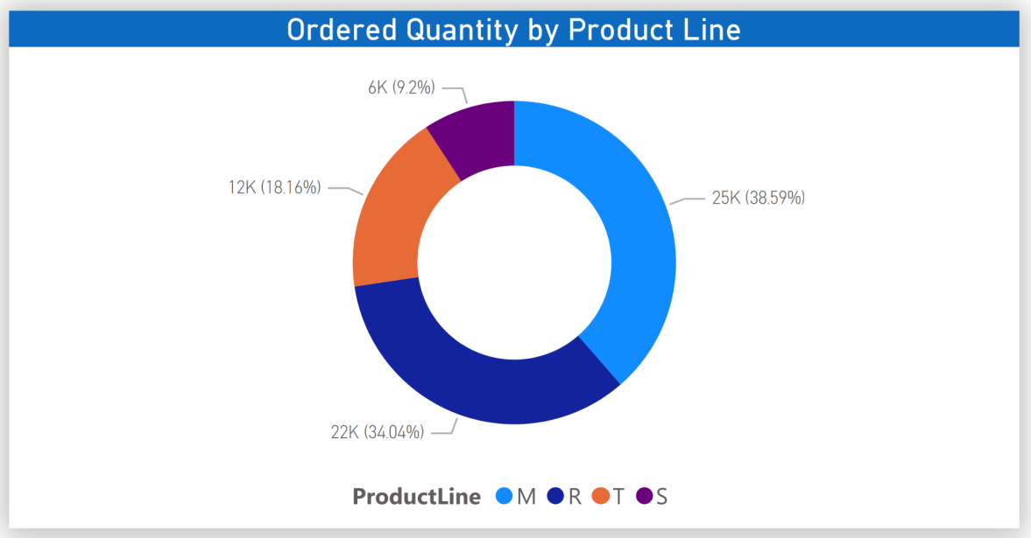

Ordered quantity by product line chart

The chart illustrates ordered quantity by product line, including: R = Road, M = Mountain, T = Touring, S = Standard. According to the chart, road was the largest line and standard was the least narrow line. In all types of product line there was only minimal change from 2012 to 2013. In 2011 and 2014, standard line was not ordered.

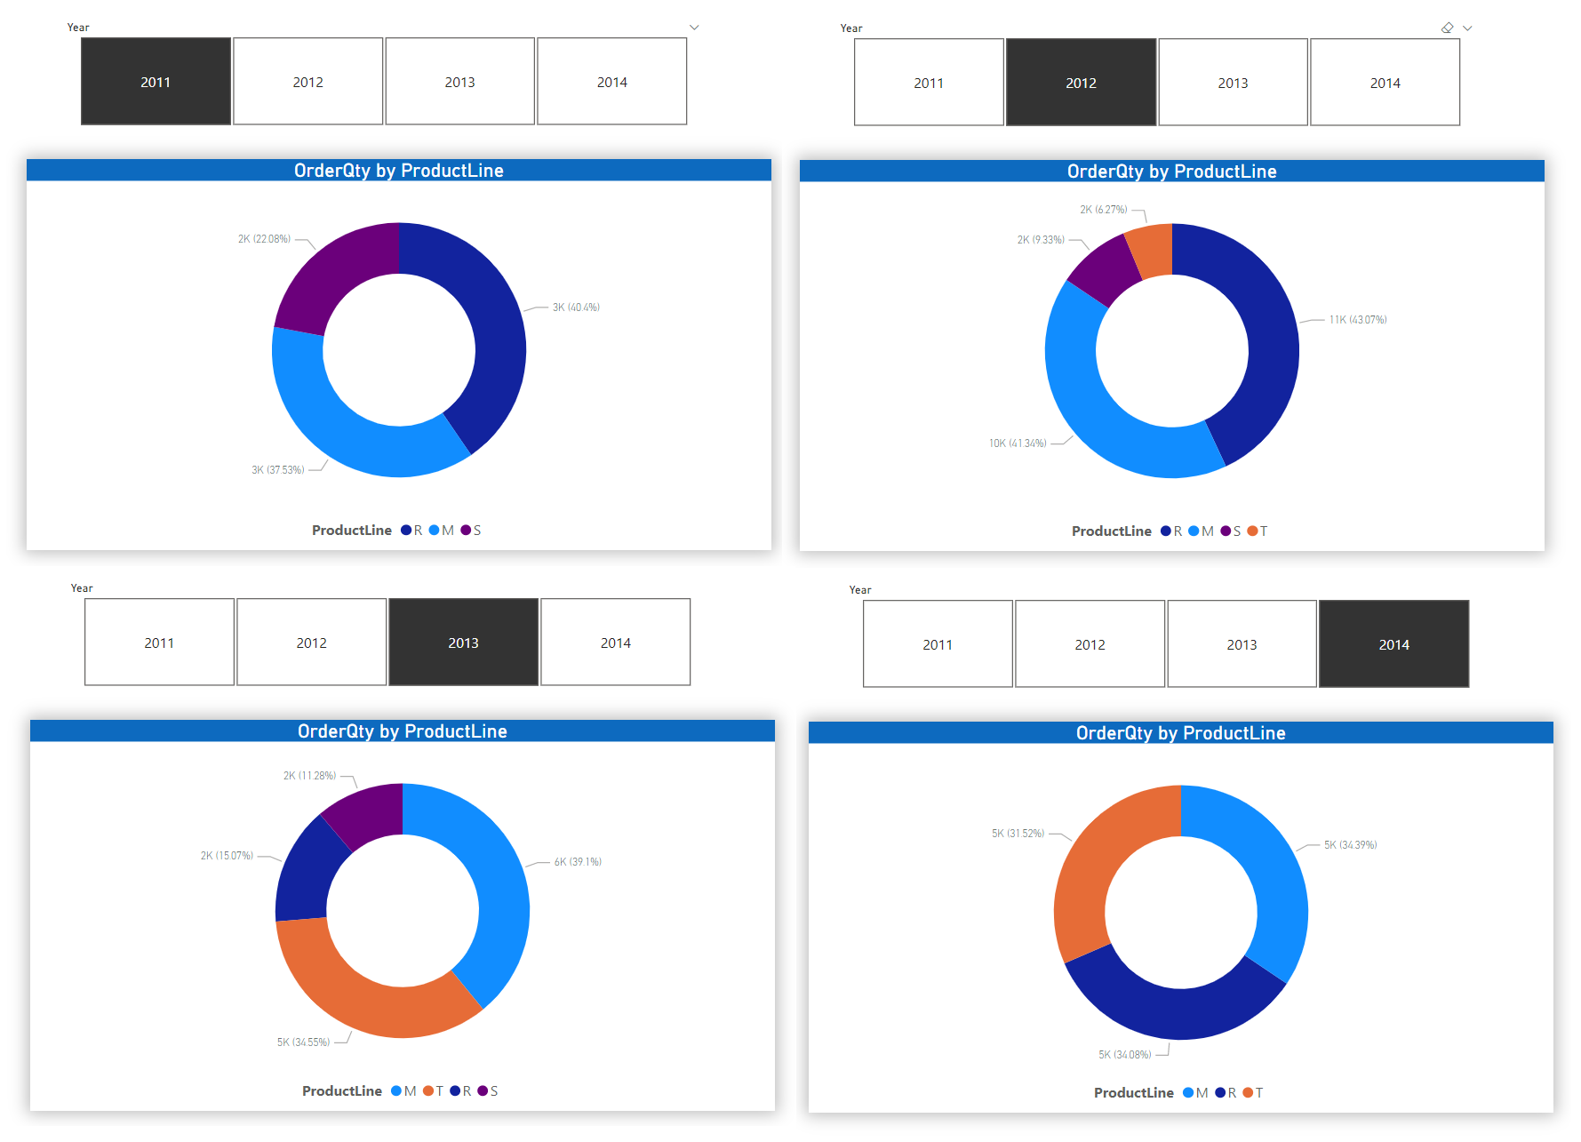

Ordered quantity by product line from 2011 to 2014 report

Based on this report, touring line increased enormously from 2012 to 2014. Road line and mountain line changed marginally. In 2014, all lines were approximately equal. This remaining maybe a good point for balance on product. However, we can not predict whether the demand for order will outperform or decline.

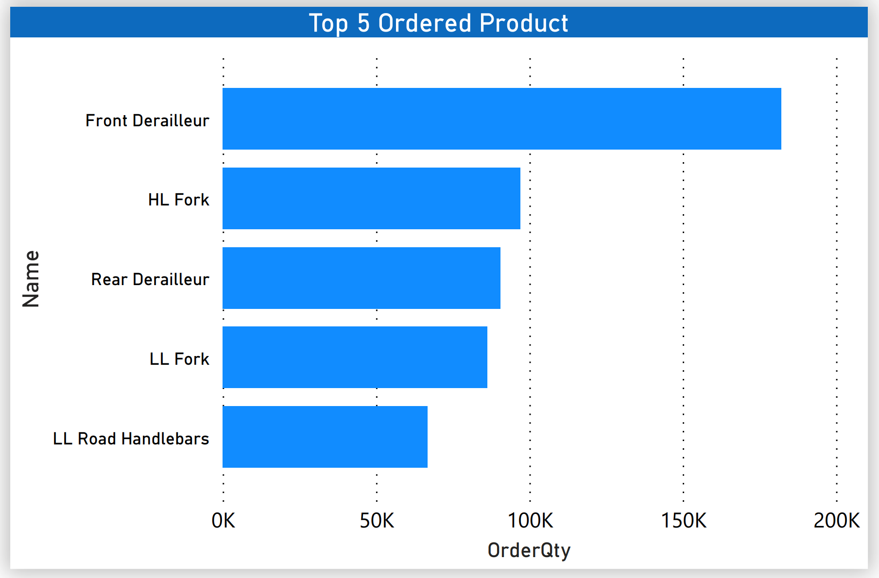

Top 5 ordered products chart

This chart shows the top 5 popular products including: Front Derailleur, HL Fork, Rear Derailleur, LL Fork and LL Road Handlebars. Front Derailleur is the highest consumed product at 182,162 items. Over 4 years, Front Derailleur was the most popular product. So, we need to promote production of this product.

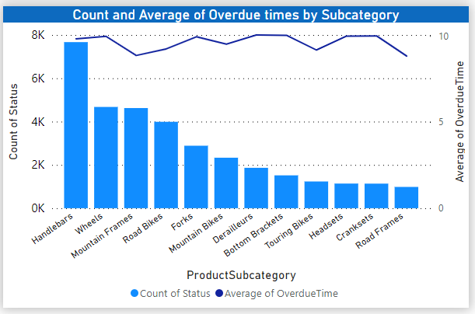

Overdue time by product subcategory chart

The chart displays overdue time of product subcategories. Monitoring the overdue times of products can support production department to evaluate planning process and improve operational efficiency. According to that chart, Handlebars was the item that are often overdue (about 7671 times). Handlebars also was the third ordered product so production department must to improve this issue by upgrading the production system. Average of overdue time was from 8 to 10 days and only minimal change between different subcategories. The problems about missing deadline in production can come from planning process estimated manufacturing capabilities in an incorrect way and production system worked inefficiently.

#### 6.2.1.2 Scrap details

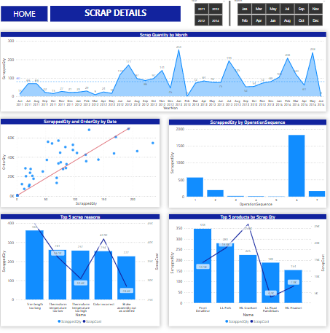

Scrap details dashboard

The first line chart of the dashboard gives us an overview of the amount of scrap over each month/year. In addition, we also combine a line of average scrap quantity of the production department, this will help us to assess whether the production situation (scrap quantity) is good or not.

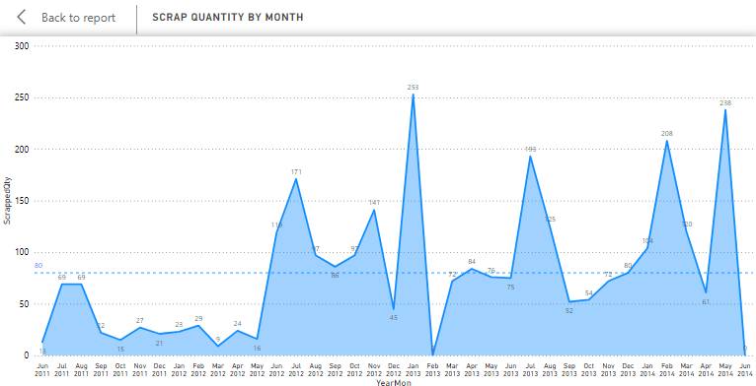

Scrap quantity by Month

Scrap quantity has its increase and decreases depending on the socio-economic situation of that time. However, in general, scrap quantity increases in the 3rd and 4th quarters of each year. This can be influenced by the number of production orders of the company.

One solution given from the charts results is that the company should focus on the working hours of machines and workers, especially during the peak production time of the 3rd and 4th quarters every year. Since production quantity is directly proportional to scrap quantity, if we want to reduce scrap quantity, we need to focus on fixing and reducing the reasons.

After analyzing the scrap quantity over time, we proceed to find out the top 5 products with the most scrap quantity as well as the top 5 scrap reasons. Attached to these quantities is the corresponding cost. The combination of line and column charts will make it easy to visualize how the amount of scrap will affect the actual costs that the company will incur.

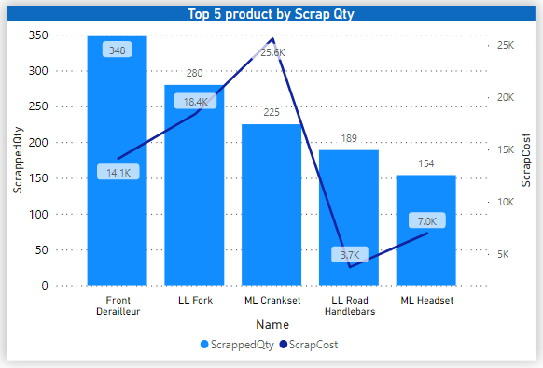

Top 5 products have the most scrap quantity

The top 5 products with the most scrap quantity belong to the product category of Component. The chart shows that each scrap quantity of different products can entail different cost ratios. For example, the product “Front Derailleur” has a higher scrap quantity than “ML Crankset” but in terms of cost it is lower than “ML Crankset”.

From that, we want to conclude that the production department needs to pay attention to improving the quality of products that affect actual production costs, such as “ML Crankset” (because it is not the top 1 about scrap quantity but generates much higher scrap costs), as well as products “LL Fork”, “Front Derailleur”,…

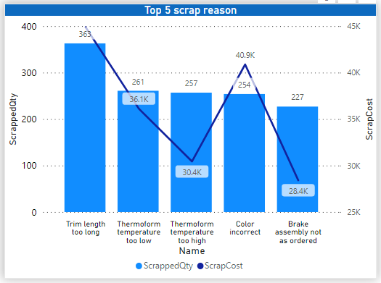

Top 5 scrap reasons

The top 5 reasons for the situation of scrap include: leading in quantity is the reason “Trim length too long” (26.65% of the total), the following 4 reasons have the same amount in total (approx. 15 – 20%) including “Thermoform temperature too low/high”, “Color incorrect” and “Brake assembly not as order”.

Besides considering the quantity, the cost for these reasons should also be taken into consideration, from the results of the chart, we suggest that Adventureworks should pay careful attention to the production process for many items. Reasons for large cost loss such as “Color incorrect” and “trim length too long”, etc. need to be given the most optimal solution (this strategy needs to consider aspects such as operation sequence, production time, expected cost, nature of scrap reasons,...).

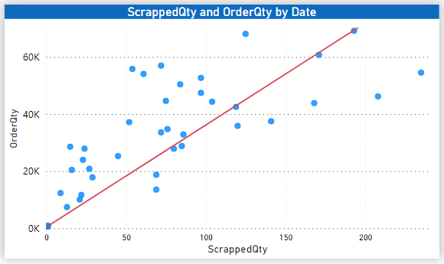

The correlation between Scrapped quantity and Order quantity by Date

This is a scatter plot, it shows the correlation between the two variables Scrap quantity and Order quantity. In addition to observing the dots (dispersion point, intersection point between 2 variables) to see the correlation, we can observe the trend line (red line).

This means that when the Order quantity increases, the Scrapped quantity also increases.

Besides analyzing the influence of product quantity as well as scrap reasons, we realize that it is necessary to study the production process. Specifically, the operation sequence and the company's monthly production cycle.

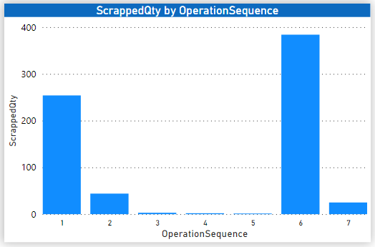

Scrap quantity by Operation sequences

This column chart shows the total scrap quantity of each operation sequence. We can see that sequence 6 accounts for the majority of the volume with 1827 scrap products. Next is sequence 1 with 567 products. And sequences 2 and 7 range from 168 to 179, while sequences 3, 4, and 5 still have the lowest level of fewer than 20 products. Since the production quantity at each sequence is also proportional to the scrap quantity, when the production quantity is large, the scrap quantity is also large. Looking at the chart, we can understand that sequence 6 is the key sequence because it has to work continuously, but the scrap quantity is also quite a lot, this can affect the revenue of each product related to this sequence.

It can be understood that sequence 6 is the place to focus on producing the "Component" product category, so with a large amount of order quantity, the scrap quantity will certainly increase. Besides, scrap reasons for this number are also quite diverse and account for almost 80% of the number of top 5 reasons.

One thing that we want to recommend to AW company is to focus on fixing (or limiting) the reasons that lead to scrap (top 5 reasons), every product that is reduced in scrap quantity will also decrease the waste costs. Not only sequence 6 but also other operation sequences.

#### 6.2.1.3 Cost Details

The Cost Details page consists of 4 charts that show an in-depth analysis of the production cost and help determine specific issues.

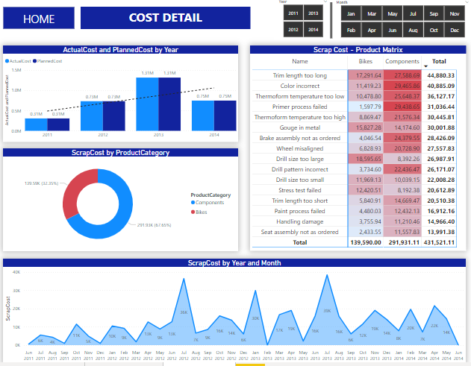

Dashboard about Cost Detail

Scap Cost - Product Matrix

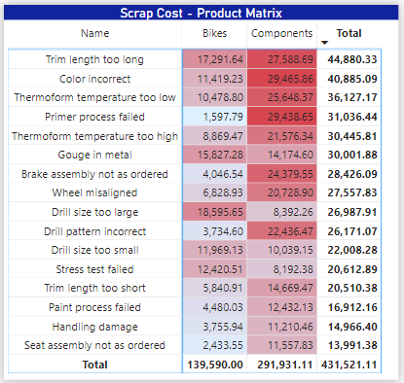

Matrix table of scrap cost for product category

The Matrix table shows the reason where exactly the waste is costing money to the company and due to which reasons. The first column provides the reason for scrap reason, while the other two columns are divided into two categories Bikes and Components. The cost is conditionally formatted showing which portion is costing more and the reason for it. There are subtotals on rows, columns and grand total for waste money.

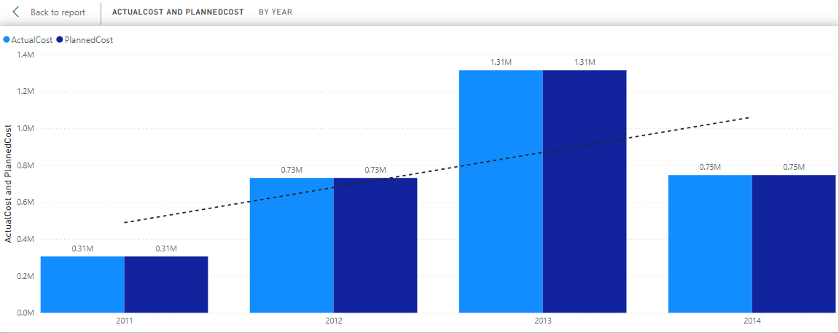

Actual Cost and Planned Cost by Year

Line and clustered column chart about actual and planned cost by year

With this chart, we can see that the actual cost is equivalent to the planned cost. There are two hypothesis here:

* Hypothesis 1: The company does very well in financial planning so that cost variance always equals 0, which means the company is never over or under the budget. That is a very good sign so the company should continue to keep up the good work.
* Hypothesis 2: For some reasons, the data of company is not reflecting the right problems. Because there are many products that are overdue but the cost and resource hours still constant. So the company should track cost more carefully.

Looking at the chart, we can also see the trend of cost over years. It increases about 500,000$/year. Based on that, we can predict that cost in the next 6 months of 2014 will increase about 1,000,000 if company does not have a solution to optimize their production process and reduce scrap quantity.

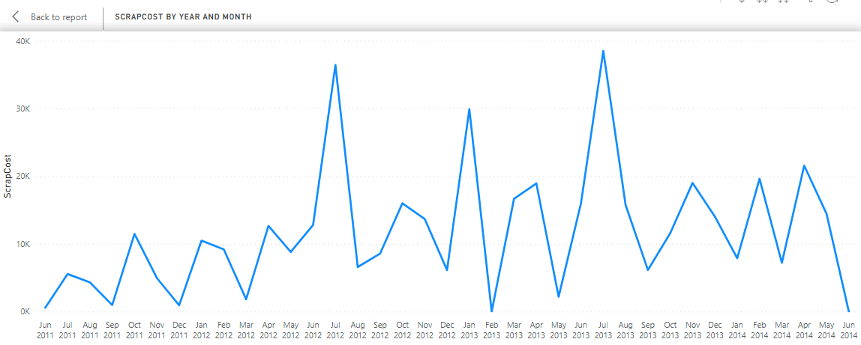

Line chart about scrap cost be year and month

﻿Comparing scrap cost on different years shows us a pattern. The peaks often occur in July, October, and January. Now, the company is in June, and base on the data of history, we can predict that the next month will have an increase in cost. Knowing this can help company planning better in the next month.

### 6.2.2 Inventory

#### 6.2.2.1 Inventory Overview

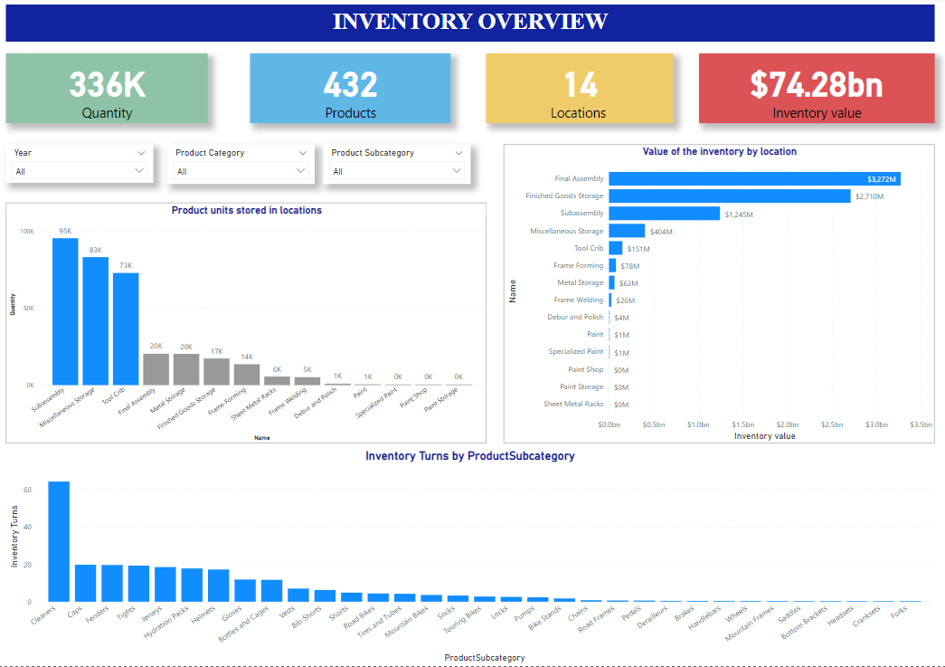

Inventory overview

With the Inventory Overview dashboard, AWs company will have an overview of the current status of inventory through cards and charts.

Cards Visual

The 4 cards represent Quantity, Products, Locations and Inventory Value, respectively. Through these 4 cards, we can see the quantity of the inventory, the total number of products, the total number of Locations and the value of the inventory (Inventory value) over time. In addition, with 3 filters: Year (filter parameters by time are the years from 2006-2020); Product Category (filter parameters according to each category of inventory), and Product Subcategory (filter parameters according to each subcategory of the inventory). inventory).

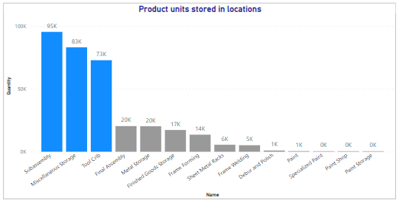

Product units stored in locations

With a clustered column chart Product units stored in locations, we will see the number of products distributed by each location.

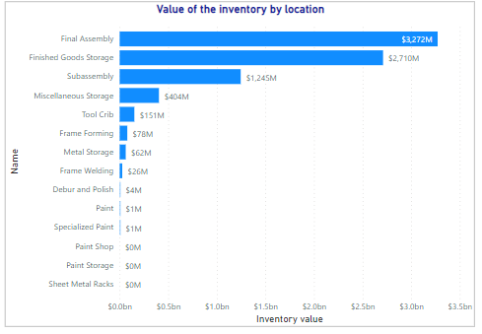

Value of the inventory by location

The stacked bar chart Value of the inventory by location shows the value of the inventory for specific locations.

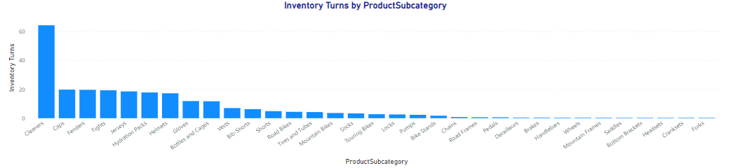

Inventory Turns by ProductSubcategory

Inventory Turns by Product Subcategory is a stacked column chart that displays inventory turnover by product category. Inventory turnover shows the frequency of product sales of the store and can assess whether a product is selling quickly or slowly, thereby making it easier to make decisions to manage the store's anti-lost goods. From the chart above, we can see that the subcategory Cleaner has the highest index, which means that the store is selling goods very quickly and demand for that item is very large. Besides, with other subcategories like Headsets, Forks, Cranksets,... have a low index, and zero means weak sales as well as low demand for the product.

With the above stacked bar chart and clustered column/bar chart, managers will have a visual view of the distribution of inventory and products according to each location, thereby being able to assess which locations are used a lot and which locations are overloaded or rarely used. Along with that, the inventory turnover chart indicator will help administrators capture trends and customer needs to adjust the purchase plan and stockpile products more reasonably.

#### 6.2.2.2 Inventory Details

In addition to dashboard of inventory overview, one of inventory details is plotted so as to provide managers more useful information in decision making.

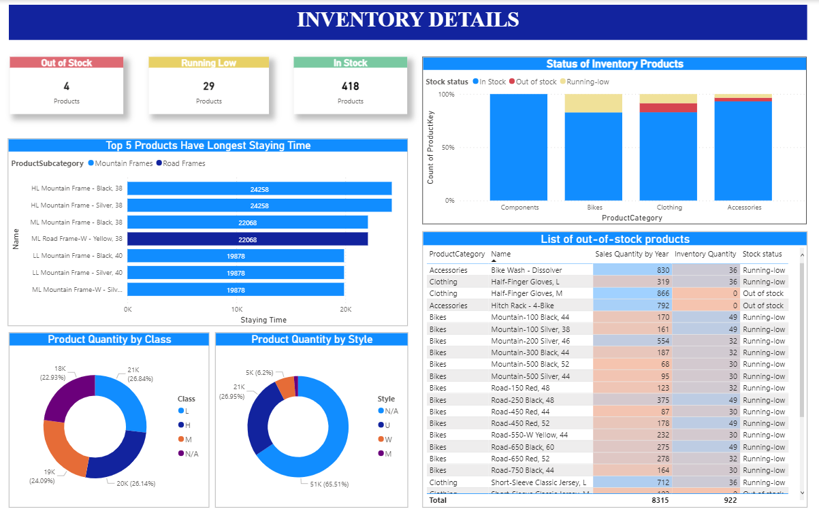

Dashboard of inventory details

The dashboard demonstrates detailed information and metrics, showing the state of inventory such as stock status of products, characteristics of inventory goods and which sellable products stay in inventory for an extended period of time. It is believed that the aforementioned information would help the production department to control the inventory more efficiently and wisely.

In order to give information at a glance, the above scorecards are put at the top of the page. Then, it is followed by other graphs.

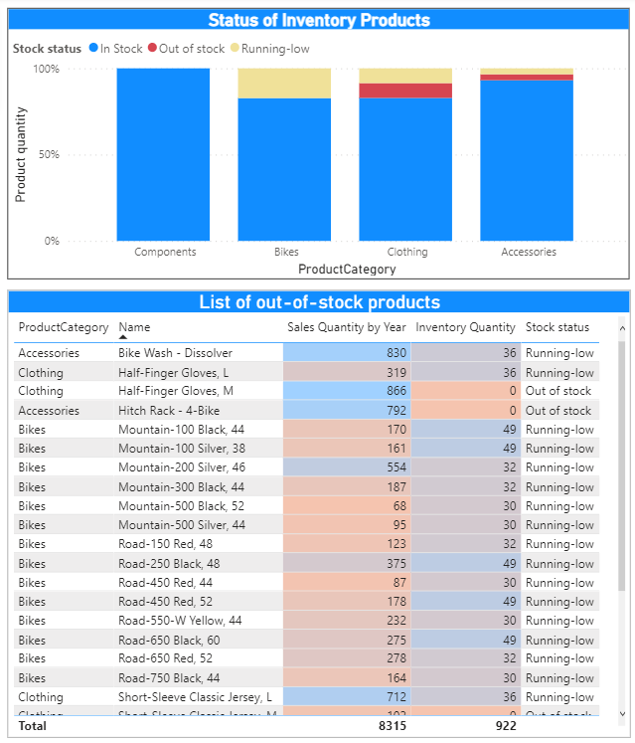  
Stock status of each product category and list of low stock products

It is vital to show the ratio of stock status in every single product category. Almost all products are in stock, particularly components whose products are completely available. It is to say that component stocks are managed well or they have not been sold and have stayed in inventory for a long time. Whereas, other categories have a small amount of running-low and nonexistent products.

For more details, a list of products that are out of stock or running low is given so that managers can compare the average annual sales amount to the current balance of inventory to make decisions for future plans. The products with low stock and high sales should be continuously restocked, in contrast, the production department has to take into consideration renewing. For example, “Half-Finger Gloves, M” and “Hitch Rack - 4-Bike” have positive sales but they are currently out of stock, therefore, they should be restocked to meet the market demand and not miss any opportunities. Besides, products that have low order quantity need more examination in adjusting the number of inputs.

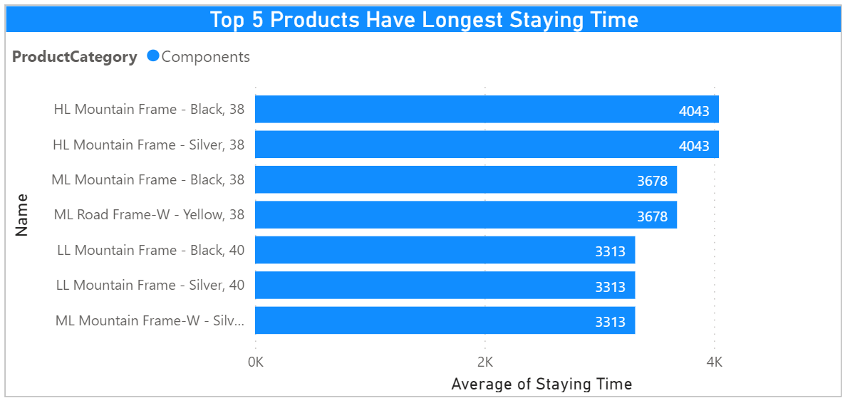

Top 5 products staying at inventory for a long period of time

As stock can not tell if products that are available are well controlled. There is a case that products have high inventory days. In other words, these products were not turned into sales quickly. The reason could be poor sales performance or purchase of too much inventory. Having too many inefficient goods can be disadvantageous to AdventureWorks. As mentioned above, component stocks were managed well or they had not been sold and have stayed in inventory for a long time although all products in the category are in stock. Then the above figure gives the answer that the top five products having the highest inventory days are components, which reach a high of 4034 days (about 11 years) . Hence, the components were not administered properly. Those products should be boosted in sales to enhance the inventory performance.

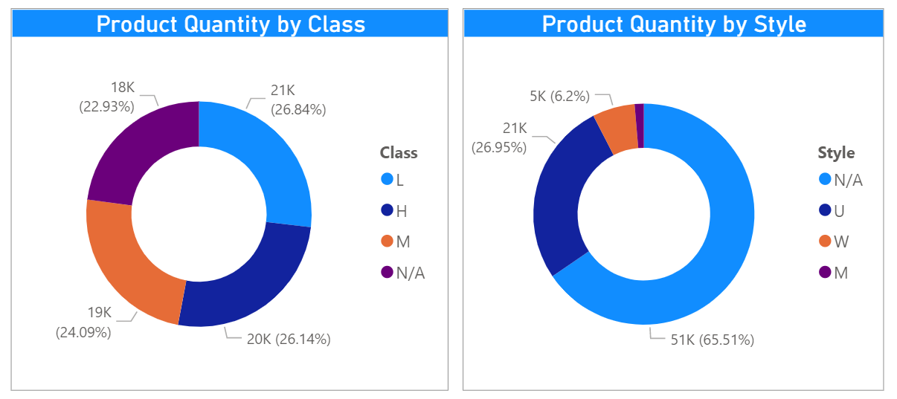

Proportion of products in terms of class and style

The charts would deliver information of how much class and style account for in inventory. Regarding the ratio of product classes, there were no significant differences in 4 classes, which are from 0.22 to 0.268. The distribution of classes was quite balance.

Taking a closer look at figure of style, the quantity of products whose style were undefined represented the highest percentage, followed by that of universal products, women's products in that order. The number of men products was the least product style stored in the inventory.

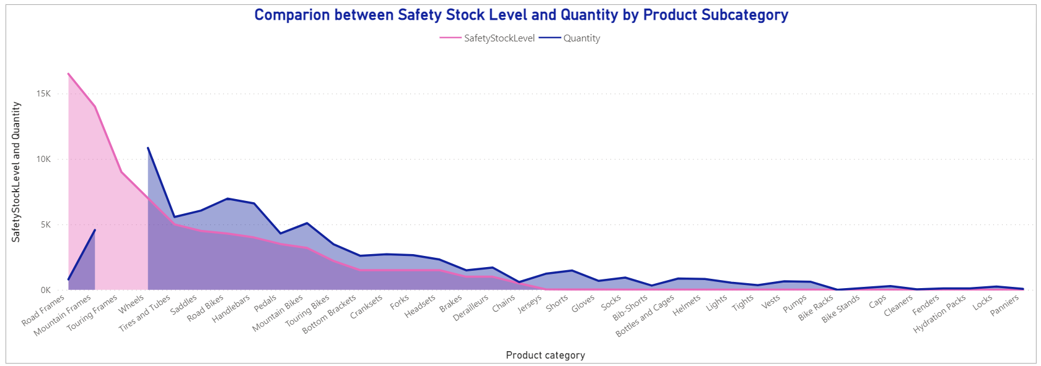

Comparison between safety stock level and quantity in subcategories

Safety stock level illustrates the minimum inventory quantity. It is to say that inventory quantity should be higher than safety stock level. From the area chart, almost subcategories stored goods in a safe level. However, some categories did not meet the safety level, having a huge gap such as road frames, mountain frames. In particular, touring frames has no quantity. These products should be planned to produce and purchase. The production department can manage the inventory better based on these metrics combined with demand of customers.

#### 6.2.2.3 Inventory Movement

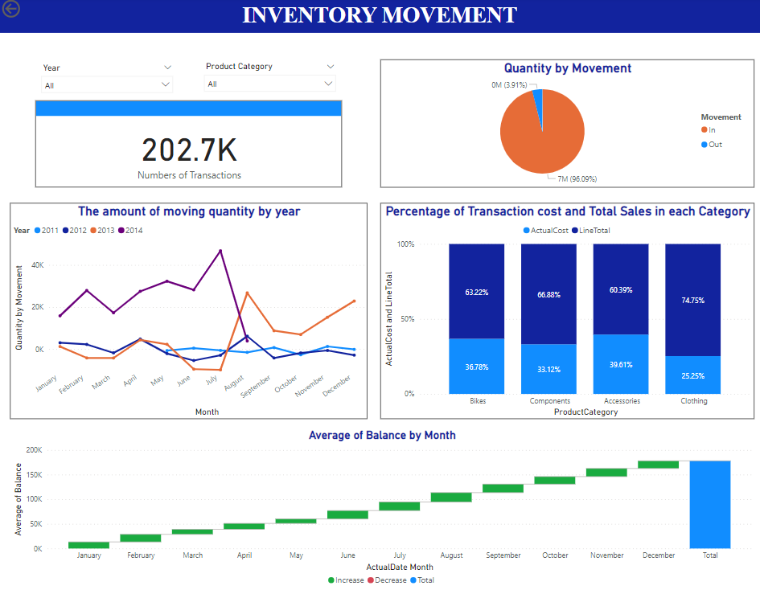

Inventory Movement Dashboard

The Inventory Movement describes the transactions that occur with the inventory by year and by Product Category.

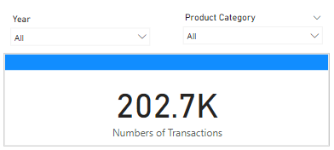

Cards Visual

With a card and a filter, users can see the number of transactions and filter data by year (Filter Year) or by product type (filter Product Category).

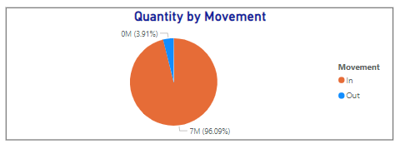

Quantity by Movement

The Pie chart, Quantity by Movement shows the ratio between the In and Out movement of the inventory. Movement In represents Work Order transaction, Out movement represents Purchase Order. For each Category, the movements are very different, with Clothing and Accessories having almost no In movement, with Bikes In and Out balanced, and Components with the majority of In movement. For example, the amount of In and Out can be seen to be very different. From 2011 to 2014, all transactions of Accessories and Clothing were Out movements.

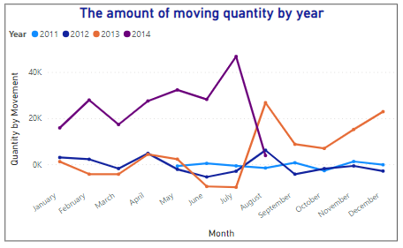

The amount of moving quantity by year

The line chart The amount of moving quantity by year shows the quantity fluctuations of inventory transactions by month of the year. Quantity by movement is sum of goods in and outs in a period. At the monthly points, if that point is above 0, the amount of goods in that is greater than the figure of goods out should show a positive value, and the “In” greater than “Out” movement volume also shows the excess in inventory compared to actual demand, and for points below the 0 mark, the amount of Out greater than In movement is equivalent to the quantity of goods in short supply compared to demand.

Notably, the numbers of moving quantity in Q1 and Q3 in 2013 experienced negative values. It is can say that:

* Positive impact
* Negative impact

In addition, according to the volatility of the line chart, the administrator can predict the trend of demand combined with the number of movements, thereby making more appropriate decisions about the production of goods or purchasing more inventory.

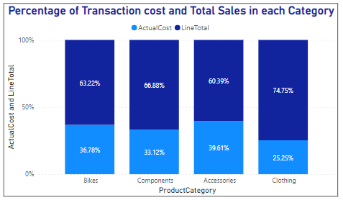

Percentage of Transaction cost and Total Sales in each Category

The stacked column chart Percentage of Transaction cost and Total Sales in each Category shows the ratio of Actual Cost (product cost) and Line total. With this chart, we can see how much the product cost (inventory) accounts for compared to the selling price, which shows the effect of inventory and transactions inventory on total sales.

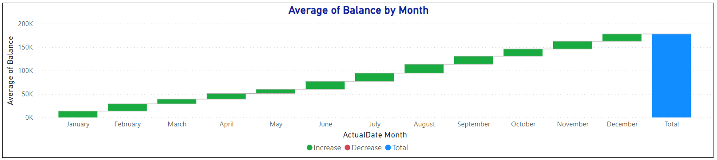

Average of Balance by Month

The waterfall chart, Average of Balance by Month shows the rise and fall of the inventory balance. It can be seen that with the average balance always increasing every month, it shows that in transactions, transaction In is always larger than transaction Out, so this index does not decrease. This proves that there is always an inventory, whether it is redundant or full.

So, from the charts in the Inventory Movement dashboard, we can predict the monthly trend of product consumption, adjust production, purchase, and sale plans, and store goods accordingly from inventory movements.

# CHAPTER 7: CONCLUSION AND FUTURE WORKS

## 7.1. Results

Overview of the results, we have completed the project and achieved the following results:

* Identify the goals, research results, and the importance of business intelligence (BI) solution for businesses
* Description, overview analysis of Adventure Cycle Works, organizational models, data storage, processing and analysis of BI solution.
* Complete the given objectives for the BI solution, and answer the questions set out to solve the problem.
* Learn and use tools to support the development of BI solutions such as PowerBI, Visual Studio SSAS, Microsoft SQL Server Management,....
* Improve teamwork and research skills
* Responsible and positive at work
* Have professional ethics in the job

## 7.2. Limitations

During the implementation of the project, we still have the following limitations.

First, because of limited knowledge and time, we have not been able to perform MDX query as planned. This partially affects the outcome of the project. Although the results have not really gone into the analysis, we have also achieved certain success.

Second, due to lack of experience, the construction of data warehouse and implementation of ETL process was overtime. Spending more time on this, delays the project and shortens the execution time of the following sections.

Finally, because the scope of the project is quite wide and the difficulty of knowledge is very large, the results are not really perfect. The results of the dashboard analysis are right in focus but have not yet gone into economic operations.

## 7.3. Future works

First of all, we continue research on MDX query and data storytelling to more complete data processing and visualization.

Second, we research deeper into economic requirements to design flexible dashboards and meet business requirements with the goal of supporting better decision making. Moreover, we want to extend interactive features in reports and nested reports.

Finally, we will learn more about the BI solution and expand the project both horizontally and in depth.

# REFERENCES

[1] SkyPoint CSG (2021). Business Intelligence Tools: A Pros and Cons Comparison Chart. Retrieved from:

<https://www.csgpro.com/blog/business-intelligence-tools-comparison-chart/>

[2] Ez Data Munch - Abhishek Sharma (2018). Define KPIs for Successful Business Intelligence. Retrieved from:

<https://ezdatamunch.com/define-kpis-successful-business-intelligence/>

[3] Red Gate Hub - Robert Sheldon (2010). Five Basic Steps for Implementing an Analysis Services Database. Retrieved from:

<https://www.red-gate.com/simple-talk/databases/sql-server/bi-sql-server/five-basic-steps-for-implementing-an-analysis-services-database/>

[4] Microsoft Docs (2022). Key Concepts in MDX (Analysis Services). Retrieved from:

<https://docs.microsoft.com/en-us/analysis-services/multidimensional-models/mdx/key-concepts-in-mdx-analysis-services>

[5] Idera. MDX - Idera Glossary. Retrieved from:

<https://www.idera.com/glossary/mdx>

[6] Hashmicro - Vania Marsha Kristiani (2021). Production Process in Business: Definition, Types, and Characteristics. Retrieved from:

<https://www.hashmicro.com/blog/what-is-production-process/>

[7] The Global Treasurer (2013). The Pros and Cons of KPIs. Retrieved from:

<https://www.theglobaltreasurer.com/2013/11/19/the-pros-and-cons-of-kpis/>

[8] ScienceDirect Topics. Transactional Data - an overview. Retrieved from:

<https://www.sciencedirect.com/topics/computer-science/transactional-data>